fCx

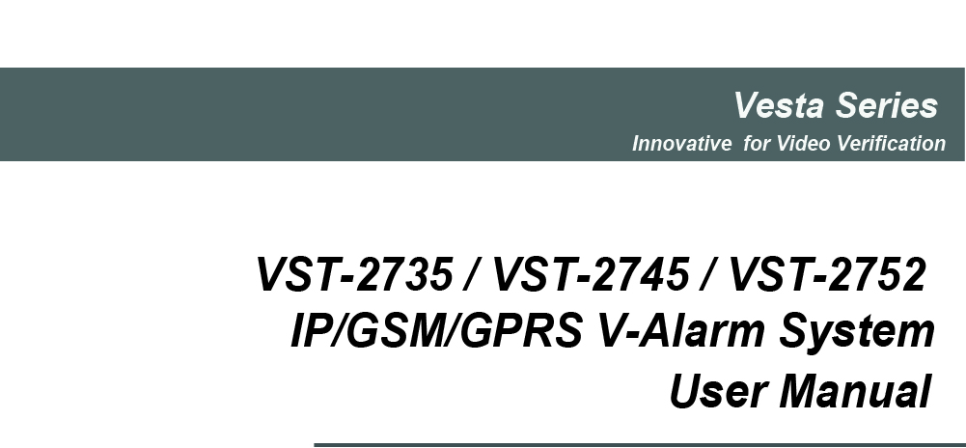
Jul-10-2013
Table of Contents

1. Application Overview 1
1.1. Identifying the Parts 1
1.2. Introduction 2
1.3. The Power Supply 2
1.5. How to Install the Control Panel 2
1.6. Three – Level Passwords 3
1.7. System Basic Operation 3
1.8. Getting Started 4
2. System Configuration 5
2.1. Walk Test 5
2.2. Install Code 5
2.3. Report Setting 5
2.4. Record Message 6
2.5. GSM Setting 6
2.6. Panel Setting 7
2.7. General Setting 10
2.8. Device +/- 11
2.9. Network Setting 15
2.10. Media Upload 16
3. Programming Menu 17
3.1. Walk Test 17
3.2. PIN Code Setting 17
3.3. Master Code 18
3.4. Temporary Code 18
3.5. Duress Code 18
3.6. General Setting 18
3.7. Device +/- 19
4. Operation 19
4.1. Entering User Menu 19
4.2. Away Arm Mode 19
4.3. Home Arm 1/2/3 Mode 20
4.4. Force Arm 20
4.5. Disarm 21
4.6. Dual Key Alarm 21
4.7. Keypad Lockdown 21
4.8. Tamper Protection 21
4.9. Stop the Alarm and Alarm Display 21
4.10. Fault Display 22
4.11. Factory Reset 22
4.12. Alarm Activation 21
4.13. SMS Remote Command 23
5. Vesta EZ Home Application 28
5.1. For iPhone 28
5.2. For Android Phone 36
6. Appendix 45
5.1. Event Code 45

1. Application Overview

1.1. Identifying the Parts
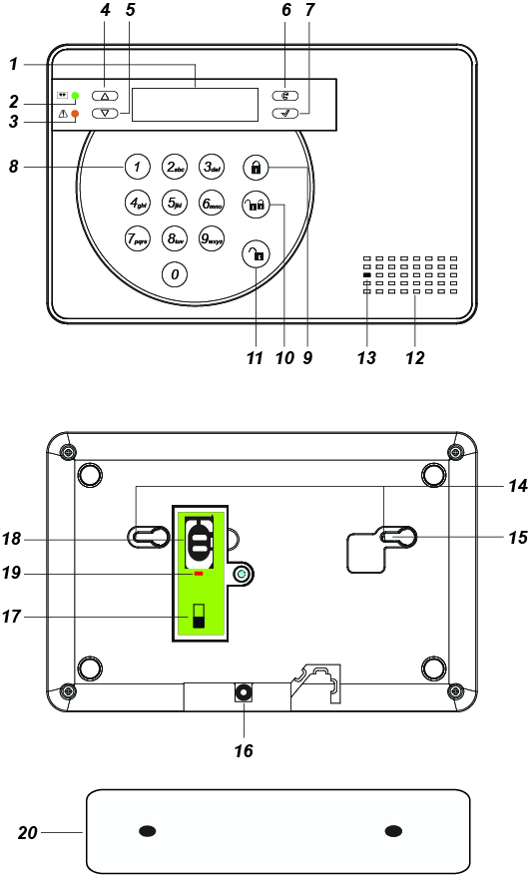

1. Backlit LCD Display
2. Green LED
ON: AC Power is on.
FLASH: AC Power failure.
OFF: Power off
3. Yellow LED
ON: Fault Indicator; the Yellow LED will light up when any fault situation is detected and turn off when all fault conditions are restored.
4.  Key
- Use this key to move the cursor and scroll the display upwards
5.  Key
- Use this key to move the cursor and scroll the display downwards.
6. Key

— Use this key for deleting a digit, canceling the selection, aborting the current screen and returning to the previous screen etc.
7. OK Key
- To confirm the keyed-in data or confirm the selection.
8. Numeric Keys
9. Away Arm Key
— Use this key to Away Arm the system.
10. Home Arm Key
— Use this key to Home Arm the system.
11. Disarm Key
— Use this key to Disarm the system.
12. Buzzer
13. Microphone

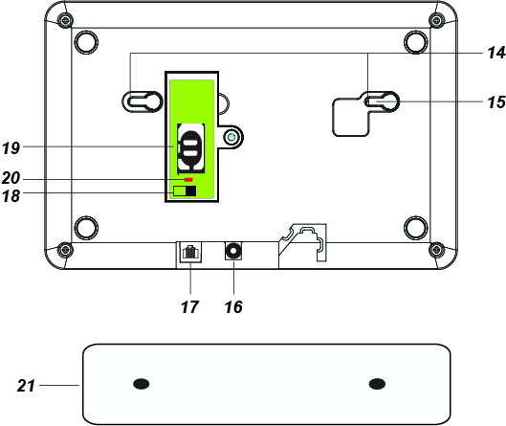

14. Mounting Holes & Tamper
15. Tamper Switch
16. DC Jack
- For connecting the DC 12V 1A power adaptor.
17. Internet Connection (VST-2735/ VST-2752 Only)
18. Battery Switch
19. GSM/GPRS SIM Card Base (VST-2745/ VST-2752 Only)
20. GSM/GPRS LED (VST-2745/VST-2752 Only)
- On for 5 seconds when power is supplied.
- Flash Slowly: GSM normal.
- Flash Quickly: GSM failure.
21. Wall Mounting Bracket
- For mounting the Control Panel on the wall.

1.2. Introduction
VST-2735/2745/2752 series Control Panels feature IP and/or GSM/GPRS reporting functions:
VST-2735 – IP Reporting
VST-2745 – GSM/GPRS Reporting
VST-2752 – IP + GSM/GPRS Reporting
The advanced IP Security System with fully integrated TCP/IP technology and Ethernet connectivity is able to take full advantage of new advances in IP Home Security and Home Automation and multi-path signalling.
Remote control of the panel is achieved by registering the panel in our Home Portal Server. With Home Portal Server, you can connect to your panel anytime, anywhere in the world through internet connection either with a computer or a smartphone using our Vesta Home application. Please refer to our Home Portal User Guide for detail about registering and using Home Portal Server.
For VST-2745 and VST-2752, SMS remote programming and command is also available to configure your panel by SMS messages. You can also use our Vesta EZ Home smartphone applications to send the SMS commands easily for basic panel functions.

- GSM/GPRS SIM card:
VST-2745 and VST-2752 Panel feature built-in GSM/GPRS communication facility to report to the Monitoring Station. To use the GSM/GPRS function, a SIM card is required.
<Note>
- Please disable the SIM card PIN code before inserting into the Control Panel.
- Please make sure the SIM card GPRS and MMS functions are activated
- Unlock the SIM card base by sliding the cover toward OPEN direction.
- Spring open the SIM card slot and insert your new SIM card.
- Replace the SIM slot onto the base lightly.
- Remember to lock the SIM card base by sliding the cover toward LOCK direction.

1.3. The Power Supply
An AC power adaptor is required to connect to a wall outlet. Be sure only to use an adaptor with the appropriate AC voltage rating to prevent component damage.
A DC 12V output and 1A switching power is generally used to power the Control Panel.
- Rechargeable Battery
- In addition to the adapter, there is a rechargeable battery inside the Control Panel that serves as a back up powering source in case of any power failure condition.
- During normal operation, the AC power adapter is used to supply power to the Control Panel and at the same time recharge the battery. It takes approximately 72 hours to fully charge the battery.
- Battery Switch is set as OFF by factory default, the battery will not be charged when AC power is connected, nor will it serve as a back-up power source when AC power is missing. You need to switch the battery to ON after supplying AC power to Control Panel.

1.5. How to Install the Control Panel
The easiest way to get to know the system and get it up and running quickly is to get all the devices and accessories programmed on a tabletop before locating and mounting them.
The Control Panel can be mounted on the wall or wherever desired. Ensure the Control Panel is fitted at approximately chest height where the display can be easily seen and the keypad convenient to operate.
- Using the 2 holes of the Wall Mounting Bracket as a template, mark off the holes’ positions.
- Drill 2 holes and fix the screws & plugs provided.
- Hook the Control Panel onto the Wall Mounting Bracket

1.6. Three – Level Passwords
In order to provide maximum security when operating the system, the Control Panel offers different levels of authorization for various situations.

User PIN Code
- The User Codes are used for users to access the alarm system for basic alarm system function. A total of 10 4-digit User Codes can be stored in the Control Panel. Each individual User can be given a name for easy recognition when viewing system events. User Names can be named when first setting them or by editing them afterwards when resetting them.
- User PIN code #1 is activated with “1234” as factory default and cannot be deleted.
- User PIN code #2~#10 are deactivated by factory default
- Whenever panel asks to key in Enter Code or, please enter your User PIN Code.

Master Code
- The Master Code has the authorization to enter Programming Mode for advanced system setting. When the display panel asks you to key in M-Code, please enter your Master Code.
- Factory default: 1111

Installer Code
- The Installer Code is for installer to program system configurations under installer menu, such as Tel. Number, Account Number.
- When the display panel asks for I-Code, please enter your Installer Code.
- Factory default: 7982

Guard Code
- The Guard Code has the same level of authorization as the PIN Code. It is designed for security personnel to access the alarm system.

Temporary Code
- The Temporary Code is designed for the use of occasional visitors. It has the same authorization level as the User PIN Code, but will be removed after one arming and disarming action.

Duress Code
- The Duress Code is specially designed for situation when the user is under personal threat. It has the same level of authorization as User PIN Code, however when a Duress Code is entered, the Control Panel will send a silent alarm report to notify that the user is being threatened or held against his will.

1.7. System Basic Operation
- While entering PIN code, if incorrect codes have been entered for 5 times. The keypad input will be prohibited for 10 minute. Any key press during this 10-minute period will reset the timer to 10 minutes.
- When entering information for system configuration, press key tol clear the field, when the field is empty, press key again to leave current screen, no information will be saved.
- When under user/programming/installer menu, if no keys are pressed within 2 minutes. VST-2752 will automatically exit the menu and return to disarm mode.
- If the Control Panel lost power supply. When the power is restored, it will resume its previoius mode.
- When programming settings, refer to the following tables to enter symbols and alphabets, press the key repeatedly until the desired symbol/alphabet appears.

1 | 1 ， ！ ？ － 【 】 @ /
2 | 2 A B C a b c
3 | 3 D E F d e f
4 | 4 G H I g h i
5 | 5 J K L j k l
6 | 6 M N O m n o
7 | 7 P Q R S p q r s
8 | 8 T U V t u v
9 | 9 W X Y Z w x y z
0 | 0 <space> / － ＆ ’ . ＋︰
 | Delete character and backspace

1.8. Getting Started
Step 1. Find a suitable location for the Control Panel to be installed.
Step 2. Insert the SIM card in to GSM module and connect the internet cable.
Step 3. Apply the AC Power. You will hear 2 short beep. Disarm will be displayed on the first line and the system time displayed on the second line of the screen indicating the system is in Disarm mode (Factory Default).
 |  |  |  |  | D | i | s | a | r | m
 |  | 0 | 0 | : | 0 | 1 |  | J | a | n |  | 0 | 1

2. System Configuration
In order to configure the Control Panel setting, you need to enter the Installer Menu. To enter the Installer Menu:
Step 1. Under Disarm mode, press any key on the numeric keypad, you will be prompted to enter User Menu.
 |  |  | E | n | t | e | r |  | C | o | d | e
 |  |  |  |  |  |  | . | . | .
Step 2. Enter a User PIN code (default is 1234) then press OK to confirm. You will enter User Menu
 | F | a | u | l | t |  | D | i | s | p | l | a | y
 | L | o | g
 | A | l | a | r | m |  | M | e | m | o | r | y
 | A | w | a | y |  | A | r | m
 | H | o | m | e |  | A | r | m |  | 1
 | H | o | m | e |  | A | r | m |  | 2
 | H | o | m | e |  | A | r | m |  | 3
 | P | - | M | e | n | u
 | I | - | M | e | n | u
Step 3. Select I-Menu and press OK to confirm. You will be prompt to enter Installer Code.
 |  | E | n | t | e | r |  | I | - | C | o | d | e
 |  |  |  |  |  | . | . | . | .
Step 4. Enter the Installer code (default is 7982) and press OK to confirm. You will enter the Installer Menu.
 | W | a | l | k |  | T | e | s | t
 | I | n | s | t | a | l | l |  | C | o | d | e
 | R | p | t | n | . | S | e | t | t | i | n | g
 | R | e | c | o | r | d |  | M | s | g
 | G | S | M |  | S | e | t | t | i | n | g
 | P | a | n | e | l |  | S | e | t | t | i | n | g
 | G | e | n | . | S | e | t | t | i | n | g
 | D | e | v | i | c | e |  | + | / | -
 | N | e | t | w | o | r | k |  | S | e | t | t | i | n | g
 | M | e | d | i | a |  | U | p | l | o | a | d

2.1. Walk Test
The Walk Test function allows you to test learned in devices. (Please refer to 2.7 Device +/- for device learning detail)
Step 1. Select Walk Test and press OK to confirm. You will enter Walk Test mode..
 |  |  | W | a | l | k |  | T | e | s | t |  |  |  | 
Step 2. Press the learn/test button on your device to transmit a test code (please refer to device manual for detail). If the Control Panel receives the test code, it will display the device information accordingly.

2.2. Install Code
This function is for you to edit the Installer code
Step 1. Select Install Code and press OK to confirm.
 |  | E | n | t | e | r |  | I | - | C | o | d | e
 |  |  |  |  |  | . | . | . | .
Step 2. Enter the new 4-digit Installer code and press OK to confirm..

2.3. Report Setting
The Report Setting function allows you to configure your report destinations. 8 reporting detinations are available for configuration.
Step 1. Select Rptn. Setting and press OK to confirm.
 |  | 1 | )
 |  | 2 | )
 |  | . | .
 |  | . | .
 |  | . | .
 |  | 8 | )
Step 2. Select the reporting number you want to program and press OK to confirm.
Step 3. Select the report type
 |  | G | S | M
 |  | S | M | S | ( | C | I | D | )
 |  | S | M | S | ( | T | E | X | T | )
 |  | I | P | ( | S | I | A | )
 |  | I | P | ( | C | I | D | )
 |  | V | o | i | c | e
 |  | D | e | l | e | t | e
- GSM: Digital reporting in CID format through GSM. (Not available for VST-2735)
- SMS(CID): SMS reporting in CID event code format. (Not available for VST-2735)
- SMS (Text): SMS reporting in text message format. (Not available for VST-2735)
- IP(SIA): IP/GPRS reporting in SIA format:
- IP(CID): IP/GPRS reporting in CID format.
- Voice: Voice message reporting.
- Delete: Choose “Delete” to remove existing report setting.
Step 4. For GSM/SMS(CID)/IP(CID/IP(SIA) setting, you will be asked to enter an account number.
Step 5. Enter the IP address for IP reporting, or telephone/mobile number for GSM/SMS reporting.
Step 6. For IP reporting, enter the port number.
Step 7. Select a group for the report destination.
- The reporting priority is based on to group number sequence. From Group 1 → Group →Group 2 → Group 3 →….etc
- When more than one reporting destinations are assigned to a group, if a report is sent to one of the detinations successfully, the system will stop reporting to the rest of the reporting destination in the same group and move on to report to the next group.
If the Control Panel fails to send report to the first detination in a group, it will move on to the next reporting destination. If all reporting destinations in the group cannot be reached, the Control Panel will move on to the next group
If the Control Panel fails to report to all reporting groups, it will start reporting from group 1 and continue retrying until one report is made successfully.
Step 8. Select the event type to be reported to this report destination.
- All: All events will be reported.
- Status: Only status events will be reported.
- Alarm: Only alarm events will be reported.

2.4. Record Message
Use the function to record your Address Message for Voice Report, the Address Message is the first message played in every voice report to notify the call recipient of the caller’s information. The maximum length of the message is 10 seconds.
Step 1. Select Record Msg and press OK to confirm.
S | t | a | r | t |  | R | e | c | o | r | d | i | n | g
 |  |  |  |  | ( | O | K | ? | )
Step 2. Press OK to start recording.
 |  | R | e | c | o | r | d | i | n | g | . | . | .
P | r | e | s | s |  | O | K |  | t | o |  | s | t | o | p
Step 3. The Control Panel will emit a beep. Start recording after the beep, speak clearly and slowly for the Control Panel to record your address. When you finish recording, press “OK” to stop recording, the recording will automatically stop when it reaches 10 second.
<NOTE>
- If you do not record your own Address Message, the system will play default alarm message when reporting. The default message is “Alarm System.”

2.5. GSM Setting
The GSM function allows you to program GRPS network and MMS settings, (This function is disabled for VST-2735)
Step 1. Select GSM Setting and press OK to confirm.
 |  | G | P | R | S |  | S | e | t | t | i | n | g
 |  | M | M | S |  | S | e | t | t | i | n | g
 |  | G | S | M |  | S | i | g | n | a | l
 |  | G | S | M |  | R | e | s | e | t
- GPRS Setting
In order to use GPRS to serve as a back-up IP Reporting method, this section will need to be programmed before reporting.
Step 1. Select GPRS Setting and press OK to confirm.
 |  | A | P | N
 |  | U | s | e | r
 |  | P | a | s | s | W | o | r | d
Step 2. Select APN and press OK to confirm.
 |  |  |  | A | P | N |  | E | d | i | t
i | n | t | e | r | n | e | t
Step 3. Enter your APN(Access Point Name) and press OK to confirm. Inquire your service provider for information if needed.
Step 4. Select User and press OK to confirm.
 |  |  | U | s | e | r |  | N | a | m | e
Step 5. Enter your log in user name and press OK to confirm. Inquire your service provider for information if needed.
Step 6. Select Password and press OK to confirm.
 |  |  |  | P | a | s | s | w | o | r | d
Step 7. Enter your log in password and press OK to confirm. Inquire your service provider for information if needed.
- MMS Setting
MMS setting is required if you want to send pictures/videos captured by PIR Camera or PIR Video Camera to mobile phones.
Step 1. Select MMS Setting and press OK to confirm.
 |  | A | P | N
 |  | U | s | e | r
 |  | P | a | s | s | w | o | r | d
 |  | U | R | L
 |  | P | r | o | x | y |  | A | d | d | r | e | s | s
 |  | P | o | r | t
Step 2. Select APN and press OK to confirm.
 |  |  |  | A | P | N |  | E | d | i | t
m | m | s
Step 3. Enter your APN(Access Point Name) and press OK to confirm. Inquire your service provider for information if needed.
Step 4. Select User and press OK to confirm.
 |  |  | U | s | e | r |  | N | a | m | e
Step 5. Enter your log in user name and press OK to confirm. Inquire your service provider for information if needed.
Step 6. Select Password and press OK to confirm.
 |  |  |  | P | a | s | s | w | o | r | d
Step 7. Enter you log in password and press OK to confirm. Inquire your service provider for information if needed.
Step 8. Select URL and press OK to confirm.
 |  |  |  |  |  | U | R | L
Step 9. Enter your MMS APN URL and press OK to confirm. Inquire your service provider for information if needed.
Step 10. Select Proxy Address and press OK to confirm.
 | P | r | o | x | y |  | A | d | d | r | e | s | s
Step 11. Enter your MMS Proxy Address and press OK to confirm. Inquire your service provider for information if needed.
Step 12. Select Port and press OK to confirm.
 |  |  |  |  |  | P | o | r | t
Step 13. Enter your MMS Port and press OK to confirm. Inquire your service provider for information if needed.
- GSM Signal
GSM Signal function displays your current GSM strength in RSSI value,
Step 1. Select GSM Signal and press OK to confirm.
 |  |  | G | S | M |  | S | i | g | n | a | l
 |  |  |  | R | S | S | I |  | = |  | 9
Step 2. The screen will display GSM strength in RSSI value from 1 to 9.
- GSM Reset
This is for you to reset your GSM module.
Step 1. Select GSM Reset and press OK to confirm.

 | A | r | e |  | y | o | u |  | s | u | r | e | ?
Step 2. The screen will ask you to confirm the action, press OK of you want to reset GSM.
Step 3. The GSM module will be reset.

2.6. Panel Setting
The Panel Setting menu allows you to program Control Panel configurations.
Step 1. Select Panel Setting and press OK to confirm.
 | K | e | y | w | o | r | d
 | P | - | w | o | r | d
 | A | C |  | F | a | i | l |  | R | e | p | o | r | t
 | J | a | m | m | i | n | g |  | r | e | p | o | r | t
 | A | u | t | o |  | c | h | e | c | k | - | i | n
 | O | f | f | s | e | t |  | p | e | r | i | o | d
 | F | o | l | l | o | w | - | o | n |  | T | i | m | e
 | H | i | g | h |  | T | e | m | p
 | L | o | w |  | T | e | m | p
 | D | a | t | e | t | i | m | e
- Keyword
The Keyword is used for receiving SMS commands from users. When a user sends a SMS command to the Control Panel, the correct keyword must be entered along with a valid User PIN code for the Control Panel to recognize the command. The Keyword is disabled by default.
Step 1. Select Keyword and press OK to confirm.
 |  |  |  | K | e | y | w | o | r | d
Step 2. The screen will display current Keyword. Enter the new keyword if you want to edit keyword, press OK to confirm the change.
- P-word
The P-word is also used for receiving SMS commands from Installers. When an installer sends a SMS command to the Control Panel, the correct P-word must be entered along with Installer code for the Control Panel to recognize the command. The P-word is “PROG” by default.
Step 1. Select P-word and press OK to confirm.
 |  |  |  |  | P | - | W | o | r | d
P | R | O | G
Step 2. The screen will display current P-word. Enter the new keyword if you want to edit keyword, press OK to confirm the change.
- AC Fail Report
This is for you to set the waiting time for the Control Panel to make report after detecting AC failure. Factory default is set to 5 minutes.
Step 1. Select AC Fail Report and press OK to confirm.
 | D | i | s | a | b | l | e
 | 1 |  | m | i | n
 | 2 |  | m | i | n
 | 3 |  | m | i | n
 | 4 |  | m | i | n
 | 5 |  | m | i | n
Step 2. The screen will display current AC fail report setting. To change the setting, select a new option and press OK to confirm.
- Jamming Report
This is for you to set whether the Control Panel should detect radio frequency interference and make report when interference is detected. Factory default is set to On. When radio jamming is detected, the Control Panel will report the event accordingly. Factory default is turned Off.
Step 1. Select Jamming report and press OK to confirm.
 | O | f | f
 | O | n
Step 2. Select to turn on/off the Jamming report function and press OK to confirm.
- Auto check-in
This is for you to set the interval time the Control Panel waits before making a regular check-in report to the programmed reporting destination. Factory Default is set to 12 hours.
Step 1. Select Auto check-in and press OK to confirm.
 |  | D | i | s | a | b | l | e
 |  | 4 |  | h | r
 |  | 8 |  | h | r
 |  | 1 | 2 |  | h | r
 |  | 1 | 6 |  | h | r
 |  | 2 | 0 |  | h | r
 |  | 2 | 4 |  | h | r
Step 2. The screen will display current Auto check-in setting. To change the setting, select a new option and press OK to confirm.
- Offset Period
This is to set the time delay before the first Auto check-in report is made whenever the Control Panel was powered off, then on again, or when Auto check-in interval time is changed.. Factory Default is set to 1 hour.
Step 1. Select Offset period and press OK to confirm.
 |  | 1 |  | h | r
 |  | 2 |  | h | r
 |  | . | . | .
 |  | . | . | .
 |  | 1 | 1 |  | h | r
 |  | 1 | 2 |  | h | r
Step 2. The screen will display current Offset period setting. To change the setting, select a new option and press OK to confirm.
- Follow-on Timer
After the Control Panel makes a GSM digital report to the Central Monitoring Station, the Central Monitoring Station can choose to enter a “Listen-in” period according to the Follow-On timer duration set here. During this period, the Central Monitoring Station will be able to listen to what is happening around the Control Panel through the microphone on the panel..
Step 1. Select Follow-on Time and press OK to confirm.
 |  | 1 |  | m | i | n
 |  | 3 |  | m | i | n
 |  | 5 |  | m | i | n
 |  | N | o |  | L | i | m | i | t
Step 2. The screen will display current Follow-on Timer setting. To change the setting, select a new option and press OK to confirm.
- High Temperature Alarm
This is for you to set the High Temperature reporting threshold. If the Control Panel has learnt in a Temperature Sensor, it will make High Temperature report and raise alarm when the temperature exceeds the threshold. When the temperature drops below set value again, the Control Panel will stop alarming and send High Temperature Restore report. Factory default is set to Disable.
Step 1. Select High Temp and press OK to confirm.
 |  | D | i | s | a | b | l | e
 |  | - | 1 | 0 |  | ° | C
 |  | 0 |  | ° | C
 |  | . | . | .
 |  | . | . | .
 |  | 5 | 0 |  | ° | C
Step 2. The screen will display current High Temperature alarm setting. To change the setting, select a new option and press OK to confirm.
- Low Temperature Alarm
This is for you to set the Low Temperature reporting threshold. If the Control Panel has learnt in a Temperature Sensor, it will make Low Temperature report and raise alarm when the temperature drops below the threshold. When the temperature rises above set value again, the Control Panel will stop alarming and send Low Temperature Restore report. Factory default is set to Disable.
Step 1. Select Low Temp and press OK to confirm.
 |  | D | i | s | a | b | l | e
 |  | - | 1 | 0 |  | ° | C
 |  | 0 |  | ° | C
 |  | . | . | .
 |  | . | . | .
 |  | 5 | 0 |  | ° | C
Step 2. The screen will display current Low Temperature alarm setting. To change the setting, select a new option and press OK to confirm.
- Date & Time
This is for you to set your time zone, date and time.
Step 1. Select Datetime and press OK to confirm.
 | T | i | m | e |  | Z | o | n | e
 | D | a | t | e |  | & |  | T | i | m | e
Step 2. The screen will display current time zone and date/time setting. To change the time zone, select Time Zone and press OK.
 | U | T | C
 | L | o | s |  | A | n | g | e | l | e | s
 | D | e | n | v | e | r
 | C | h | i | c | a | g | o
 | N | e | w |  | Y | o | r | k
 | M | o | n | c | t | o | n
 | L | o | n | d | o | n
 | P | a | r | i | s
 | I | s | t | a | n | b | u | l
 | M | o | s | c | o | w
 | T | o | k | y | o
 | S | y | d | n | e | y
Step 3. The screen will display current time zone setting, To change the setting, select a new option and press OK to confirm.
Step 4. Select Date & Time to edit Control Panel date and time.
 |  | D | a | t | e |  | & |  | T | i | m | e
2 | 0 | 1 | 3 | / | 0 | 3 | / | 2 | 2 | / | 0 | 9 | : | 1 | 1
Step 5. The current date and time will be displayed, you will begin by editing year. Press Up or Down button to change current year, press OK to continue to edit month/date/hour/ minute.

2.7. General Setting
The General Setting menu allows you to program Control Panel’s alarm related settings
Step 1. Select Gen. Setting and press OK to confirm.
 |  | F | i | n | a | l |  | D | o | o | r
 |  | A | r | m |  | F | a | u | l | t |  | T | y | p | e
 |  | T | a | m | p | e | r |  | A | l | a | r | m
 |  | E | n | t | r | y |  | T | i | m | e
 |  | E | x | i | t |  | T | i | m | e
 |  | A | l | a | r | m |  | L | e | n | g | t | h
 |  | S | u | p | e | r | v | i | s | i | o | n
 |  | S | o | u | n | d |  | S | e | t | t | i | n | g
- Final Door
If set to On, when the system is Away Armed with a Door Contact set to Entry attribute, the system will automatically arm the system once the Door Contact is closed even if the entry delay timer has not expired yet.
If set to Off, When the system is Away Armed with a Door Contact set to Entry attribute, the system will only arm the system after the entry delay timer expires. (Factory Default)
Step 1. Select Final Door and press OK to confirm.
 |  | O | f | f
 |  | O | n
Step 2. Select to turn On or Off the Final Door option.
- Arm Fault Type
Confirm: When set to Confirm, If you attempt to arm when a fault exists within the system, the arming action will be prohibited, and a message will be displayed “Fault exists! Please Confirm!” You need to arm the system again to confirm your action and arm the system. (Factory Default)
Direct Arm: When set to Direct Arm, If you attempt to arm when a fault exists within the system, the system will enter selected arm mode without further notification about fault events.
Step 1. Select Arm Fault Type and press OK to confirm.
 |  | C | o | n | f | i | r | m
 |  | D | i | r | e | c | t |  | A | r | m
Step 2. Select either Confirm or Direct Arm, and press OK to confirm.
- Tamper Alarm
Away Arm: Tamper alarm will only be activated when tamper switch is triggered under Away Arm mode (Tamper event will still be reported normally in Home/Disarm mode).
(Factory Default)
Always: Tamper alarm will be activated whenever tamper switch is triggered.
Step 1. Select Tamper Alarm and press OK to confirm.
 |  | A | w | a | y |  | A | r | m
 |  | A | l | w | a | y | s
Step 2. Select either Away Arm or Always, and press OK to confirm.
- Entry Time
If a device set to Entry attribute is triggered when the system is armed, the Control Panel will begin an Entry Delay countdown timer according to your Entry Time setting. The system must be disarmed before the timer expires or an alarm will be activated. The Entry Timer for Away Arm/Home Arm 1/Home Arm 2/ Home Arm 3 can be programmed separately.
(Factory Default is 10 seconds)
Step 1. Select Entry Time and press OK to confirm.
 |  | A | w | a | y |  | A | r | m
 |  | H | o | m | e |  | A | r | m |  | 1
 |  | H | o | m | e |  | A | r | m |  | 2
 |  | H | o | m | e |  | A | r | m |  | 3
Step 2. Select an arm mode to edit its Entry Time, press OK to confirm.
 | D | i | s | a | b | l | e
 | 1 | 0 |  | s | e | c
 | . | . | .
 | . | . | .
 | 7 | 0 |  | s | e | c
Step 3. The screen will display current setting. To change the setting, select a new option and press OK to confirm..
- Exit Time
When you arm the system, the Control Panel will begin an Exit Delay countdown timer according to your Exit Time setting, and enter selected arm mode after the timer expires.
(Factory Default is 10 seconds)
Step 1. Select Exit Time and press OK to confirm.
 |  | A | w | a | y |  | A | r | m
 |  | H | o | m | e |  | A | r | m |  | 1
 |  | H | o | m | e |  | A | r | m |  | 2
 |  | H | o | m | e |  | A | r | m |  | 3
Step 2. Select an arm mode to edit its Exit Time, press OK to confirm.
 | D | i | s | a | b | l | e
 | 1 | 0 |  | s | e | c
 | . | . | .
 | . | . | .
 | 7 | 0 |  | s | e | c
Step 3. The screen will display current setting. To change the setting, select a new option and press OK to confirm..
- Alarm Length
When an alarm is activated, both the Control Panel siren and external siren will raise alarm according to the Alarm Length setting. (Factory Default is 3 minutes.)
Step 1. Select Alarm Length and press OK to confirm.
 | D | i | s | a | b | l | e
 | 1 |  | m | i | n
 | . | . | .
 | . | . | .
 | 1 | 5 |  | m | i | n
Step 2. The screen will display current setting. To change the setting, select a new option and press OK to confirm.
- Supervision
Set the supervision timer for accessory devices, if no supervision signal is received within set duration for a certain device, the Control Panel will report the situation accordingly. (Factory Default is 12 hour)
Step 1. Select Supervision and press OK to confirm.
 | D | i | s | a | b | l | e
 | 4 |  | h | r
 | 6 |  | h | r
 | . | . | .
 | . | . | .
 | 1 |  | d | a | y
Step 2. Select your desired Supervision time, press OK to confirm.
- Sound Setting
This function allows you to program various sound
Step 1. Select Sound Setting and press OK to confirm.
 |  | D | o | o | r |  | C | h | i | m | e
 |  | E | n | t | r | y |  | A | r | m
 |  | E | n | t | r | y |  | H | o | m | e
 |  | E | x | i | t |  | A | r | m
 |  | E | x | i | t |  | H | o | m | e
 |  | W | a | r | n | i | n | g |  | B | e | e | p
Step 2. Select the function you want to edit and press OK to confirm. Available options include:
 | O | f | f
 | L | o | w
 | M | e | d | i | u | m
 | H | i | g | h
- Door Chime: If not turned off, the Control Panel will sound a door chime sound when a Door Contact set to Entry attribute is activated in Disarm mode.
- Entry Arm: If not turned off, the Control Panel will sound beeping sounds when a Door Contact set to Entry attribute is activated in Away Arm mode.
- Entry Home: If not turned off, the Control Panel will sound beeping sounds when a Door Contact set to Entry attribute is activated in Home Arm mode.
- Exit Arm: If not turned off, the Control Panel will sound beeping sounds when during Exit Delay Timer for Away Arm mode.
- Exit Home: If not turned off, the Control Panel will sound beeping sounds when during Exit Delay Timer for Away Arm mode.
- Warning Beep: If not turned off, the Control Panel will sound beeping sounds every 30 seconds when fault exists within system.

2.8. Device +/-
Devices +/- menu allows you to add/change/delete all available devices. A total of 40 devices can be included in the Control Panel.
Step 1. Select Device +/- and press OK to confirm.
 | A | d | d |  | D | e | v | i | c | e
 | E | d | i | t |  | D | e | v | i | c | e
 | R | e | m | o | v | e |  | D | e | v | i | c | e
 | P | r | o | g | r | a | m |  | S | i | r | e | n
- Add Device
Use this function in include new device into the Control Panel.
Step 1. Select Add device +/- and press OK to confirm.
 | P | u | s | h |  | B | u | t | t | o | n |  | O | n | 
 | D | e | v | i | c | e |  | t | o |  | A | d | d
Step 2. Press the learn button on the device you want to learn in to transmit a learn code, please refer to the device manual for detail.
Step 3. If the learning code is received successfully by the Control Panel, the device information will be displayed on the LCD screen. Press OK to add the device into Control Panel.
 | D | e | t | e | c | t | e | d |  | ( | O | k | ? | )
 | D | o | o | r |  | C | o | n | t | a | c | t
Step 4. Repeat Step 1~3 to learn in other devices.
- Edit Device
Use this function edit the devices learnt into the Control Panel in Add Device.
Step 1. Select Edit device +/- and press OK to confirm.
Step 2. Devices that have already been learnt in will be displayed along with their zone number (Z01, Z02…etc).
 | D | C |  | Z | 0 | 1
 | I | R |  | Z | 0 | 2
<NOTE>
- The available of devices are listed as followings:
  - Door Contact --- DC
  - PIR Sensor --- IR
  - Pet Immune PIR Sensor--IRP
  - External PIR - -EIR
  - Remote Controller --- RC
  - Carbon Monoxide --- CO
  - Smoke Detector --- SD
  - Water Sensor --- WS
  - Panic Button --- PB
  - Night Switch --- NS
  - Remote Keypad --- KP
  - Indoor Siren --- SR
  - Outdoor Bellbox --- BX
  - Power Switch --- PSS
  - Power Swich Meter --- PSM
  - PIR Camera --- SV
Step 3. Step the device you want to edit, press OK to confirm.
 | B | u | r | g | l | a | r
 | H | o | m | e |  | O | m | i | t
 | H | o | m | e | 1 | / | 2 |  | O | m | i | t
 | H | o | m | e | 1 | / | 3 |  | O | m | i | t
 | H | o | m | e |  | A | c | c | e | s | s
 | D | e | l | a | y |  | Z | o | n | e
 | A | w | a | y |  | O | n | l | y
 | E | n | t | r | y
 | A | w | a | y |  | E | n | t | r | y
 | 2 | 4 |  | H | R
 | F | i | r | e
 | M | e | d | i | c | a | l | / | E | m | g | .
 | W | a | t | e | r
 | S | e | t | / | U | n | s | e | t
 | S | i | l | e | n | t |  | P | a | n | i | c
 | P | e | r | s | o | n | a | l |  | A | t | t | .
Step 4. You will enter attribute setting page for the device. The device attribute determines this device’s behavior, please refer to attribute list below to select an attribute, Factory Default is set to Entry for Door Contact and PIR Sensor
- Burglar
- When the system is in any Arm mode, if a “Burglar” device is triggered, a “Burglar Alarm” will be activated immediately and reported.
- Home Omit
- When the system is in Home Arm 1/2/3 mode, if a “Home Omit” device is triggered, the Control Panel will not raise alarm. It will still send a report for this event
- When the system is in Full Arm mode, if a “Home Omit” device is triggered, the Control Panel will respond in the same way as if a “Burglar” device is triggered.
- Home 1/2 Omit
- When the system is in Home Arm 1/2 mode, if a “Home 1/2 Omit” device is triggered, the Control Panel will not respond. It will still send a report for this event
- When the system is in Away Arm or Home Arm 3 mode, if a “Home 1/2 Omit” device is triggered, the Control Panel will respond in the same way as if a “Burglar” device is triggered.
- Home 1/3 Omit
- When the system is in Home Arm 1/3 mode, if a “Home 1/3 Omit” device is triggered, the Control Panel will not respond. It will still send a report for this event
- When the system is in Away Arm or Home Arm 2 mode, if a “Home 1/2 Omit” device is triggered, the Control Panel will respond in the same way as if a “Burglar” device is triggered.
- Home Access
- When the system is in Home mode, if a “Home Access” device is triggered, the Control Panel will start an Entry Delay period to give enough time to disarm the system. It will also send a report for this event
- When the system is in Full Arm mode, if a “Home Access” device is triggered, the Control Panel will start a Burglar Alarm and a burglar message will be reported.
- Delay Zone
- When the system is in any Arm mode, if a “Delay Zone” device is triggered, a “Burglar Alarm” will be activated immediately and reported.
- When the system is in any Armed mode, and the Control Panel is counting down the Entry Delay, if a “Burglar” device is triggered, the Control Panel will not respond.
- During the Exit Delay period, if a “Burglar” device is triggered, the Control Panel will not respond .
- Away Only
- When the system is in Away Arm mode, if an “Away Only” device is triggered, a “Burglar Alarm” will be activated immediately and reported.
- When the system is in any Home Arm mode, if an “Away Only” device is triggered, the Control Panel will not respond.
- During the Entry Delay or Exit Delay period, if an “Away Only” device is triggered, the Control Panel will not respond .
- Entry
- When the system is in any Arm mode, if an “Entry” device is triggered, the Control Panel will start an Entry Delay countdown timer for the user to disarm the system.

- After the delay period has expired and no correct PIN code has been entered, the Control Panel will activate a “Burglar Alarm” and the event will be reported.
- When the system is in Disarm mode, if a “Entry” is triggered, the Control Panel will make a “ding-dong” Door Chime sound (if Door Chime function is not disabled).
- Away Entry
- When the system is in Away Arm, if an “Away Entry” device is triggered, the Control Panel will start an Entry Delay countdown timer for the user to disarm the system.
- After the delay period has expired and no correct PIN code has been entered, the Control Panel will activate a “Burglar Alarm” and the event will be reported.
- When the system is in Disarm mode, if a “Entry” is triggered, the Control Panel will make a “ding-dong” Door Chime sound (if Door Chime function is not disabled).
- When the system is in any Home Arm mode, if an “Away Entry” device is triggered, the Control Panel will not respond.
- During the Entry Delay or Exit Delay period, if an Away Entry device is triggered, the Control Panel will not respond
- 24 Hour
- The 24 Hour device is active all the time and does not have to be armed or disarmed. An Event Code of #130 will be reported with trigger.
- Fire
- The Fire device is active all the time and does not have to be armed or disarmed. An Event Code of #111 will be reported with trigger.
- Medical Emergency
- A Medical Emergency device is active all the time and does not have to be armed or disarmed. An Event Code of #101 will be reported with trigger.
- Water
- The Water device is active all the time and does not have to be armed or disarmed. An Event Code of #154 will be reported with trigger.
- Set/Unset (For Door Contact Only)
- If the Door Contact is set to Set/Unset, the system will be disarmed when the Door Contract is triggered, and armed when Door Contact is closed.
<Note>
    - Please refer to Normal Open/Normal Close section below for further detail.
- Silent Panic
- If the device attribute is set as Silent Panic, when the device is activated, the Control Panel will report a Slient Panic alarm without sounding an audible siren. An event code of 122 will be reported.
- Personal Attack
- If the device attribute is set as Personal Attack, when the device is activated, the Control Panel will activate an alarm and report an event code of 120 will be reported.
Step 5. Select if you want to bypass the device or not. Bypassed device will not trigger alarm when activated. Press OK to confirm. Factory Default is Normal.
 | N | o | r | m | a | l
 | B | y | p | a | s | s
Step 6. Select to on or off latch report. When turned on, the Control Panel will send a report if the device is triggered. Press OK to confirm.
 | L | a | t | c | h |  | R | p | t |  | O | f | f
 | L | a | t | c | h |  | R | p | t |  | O | n
Step 7. Enter a name for the device, press OK to confirm.
 |  |  | E | d | i | t |  | n | a | m | e
- Remove Device
Use this function remove a leant in device.
Step 1. Select Remove Device +/- and press OK to confirm.
Step 2. The screen will display learnt in device list. Select the device you want to remove, press OK to confirm.
- Program Siren
The program siren functions allows you to learn in siren/bellbox and program their behaviour.
 | L | e | a | r | n |  | S | i | r | e | n
 | S | i | r | e | n |  | T | a | m | p | . | O | n
 | S | i | r | e | n |  | T | a | m | p | . | O | f | f
 | C | o | n | f | i | r | m |  | O | n
 | C | o | n | f | i | r | m |  | O | f | f
 | E | n | t | r | y |  | S | n | d | . | O | n
 | E | n | t | r | y |  |  | S | n | d | . | O | f | f
- Learn Siren: In order to learn a Siren into the Control Panel, the Control Panel must first learn in a device of any kind.

Step 1. Put the siren into learning mode, please refer to the Siren manual for detail.
Step 2. Select Learn Siren, press OK to confirm.
Step 3. The Control Panel will transmit learning code to the siren. If the siren receives the learn code, it will react accordingly, please refer to your siren manual for detail.
<Note>
    - For SR-15 or BX-15, please learn in the siren according to the instruction in Add Device.
- Siren Tamper On/Off
Siren Tamp.On: When selected, the Siren’s tamper protection will be enabled.
Siren Tamp.Off: When selected, the Siren’s tamper protection will be disabled.
- Confirm On/Off
Confirm On: When selected, the Siren will emit beeping sound when the system is armed or disarmed.
Confirm Off: When selected, the Siren will not emit beeping sound when the system is armed or disarmed.
- Entry Sound On/Off
Entry Snd.On: When selected, the Siren will emit beeping sound during Entry Delay countdown timer
Entry Snd.On Off: When selected, the Siren will not emit beeping sound during Entry Delay Countdown Timer

2.9. Network Setting
Program your network and email SMTP setting under this menu.
Step 1. Select Network Setting, press OK to confirm
 | D | H | C | P
 | I | P |  | A | d | d | r | e | s | s
 | S | u | b | n | e | t |  | M | a | s | k
 | G | a | t | e | w | a | y
 | D | N | S
 | S | N | T | P
 | I | n | t | e | r | v | a | l
 | S | M | T | P
 | F | r | o | m
- DHCP (Disabled for VST-2745)
On: If DHCP is set to On, the Network will obtain the IP address automatically with a valid Network DHCP Server. You do not need to do any settings. You can only set DHCP to On if your Network environment supports DHCP. It will automatically generate all network information.
Off: If DHCP is set to Off, you neet to enter the Network information manually for IP Address, Subnet mask, Gateway, and DNS. Please make sure that you have obtained all required values for your Network environment. Contact local service provider if necessary
- IP Address/Subnet Mask/Gateway/DNS (Disabled for VST-2745)
You only need to configure these settings if DHCP is set to Off.
Step 1. To edit the setting, select the option to edit and press OK to confirm..
Step 2. Select to either edit or delete the setting, press OK to confirm..
 | E | d | i | t
 | D | e | l | e | t | e
Step 3. If you choose to Edit the setting, proceed to enter the new information, press OK to confirm.
If you choose to delete the setting, the information will be removed
- SNTP
The SNTP setting is for you to enter an internet time server IP to synchronize and update Control Panel time automatically according to set interval time. Factory Default is: pool.ntp.org.
Step 1. To edit the setting, select t SNTP and press OK to confirm..
Step 2. Select to either edit or delete the setting, press OK to confirm..
 | E | d | i | t
 | D | e | l | e | t | e
Step 3. If you choose to Edit the IP Address, press OK to confirm.
 |  |  | I | P |  | A | d | d | r | e | s | s
p | o | o | l | . | n | t | p | . | o | r | g

If you choose to delete the setting, the current IP will be removed

- Interval
Set the interval time for SNTP setting to update Control Panel time
Step 1. To edit the setting, select t Interval and press OK to confirm.
Step 2. Select your desired interval time, press OK to confirm..
 | 4 |  | h | o | u | r
 | 8 |  | h | o | u | r
 | 1 | 2 |  | h | o | u | r
 | 1 | 6 |  | h | o | u | r
 | 2 | 0 |  | h | o | u | r
 | 2 | 4 |  | h | o | u | r
- SMTP
The SMTP setting is for you to program the mail server related settings. The email account you set here would be used to email the triggered images/videos from PIR Camera/Video Camera. For email destination, please refer to Media Upload section.
Step 1. To edit the email information, select SMTP and press OK to confirm.
Step 2. Select to either edit or delete the setting, press OK to confirm..
 | E | d | i | t
 | D | e | l | e | t | e
Step 3. If you choose to Edit the email information, press OK to confirm.
 |  |  | S | M | T | P
If you choose to delete the setting, the current email information will be removed
<Note>
    - The format of SMTP setting is: smtp://user:password@example.com
    - SMTP setting must be entered in all lowercase letters
- From
This is for you to set the email account used to send captured picture/video. This setting should be entered along with SMTP setting.
Step 1. To edit the email information, select From and press OK to confirm.
Step 2. Select to either edit or delete the setting, press OK to confirm..
 | E | d | i | t
 | D | E | l | e | t | e
Step 3. If you choose to Edit the email account, press OK to confirm.
 |  | E | m | a | i | l |  | a | c | c | o | u | n | t
If you choose to delete the setting, the current email account will be removed
<Note>
    - The format of From setting is: name@example.com
    - From setting must be entered in all lowercase letters

2.10. Media Upload
The Media Upload menu allows you to set the destination for the Control Panel to deliver captured picture/video from PIR Camera or PIR Video Camera.
Step 1. To edit the setting, select Media Upload and press OK to confirm.
 | 1 | )
 | 2 | )
 | 3 | )
 | 4 | )
 | 5 | )
 | P | r | e | f | i | x
- 1~5
There are 5 upload destinations available for you to program.
Step 1. Select one of the upload destination from 1~5, press ok to confirm.
Step 2. Select to either edit or delete the setting, press OK to confirm..
 | E | d | i | t
 | D | e | l | e | t | e
Step 3. If you choose to edit the setting, enter an email address, FTP address, or mobile number for MMS delivery.
- Email: In order to sent the picture/video by email, the SMTP and From setting must be completed first. The email upload format is: mailto: user@example.com
- MMS: In order to sent the picture/video to a mobile number the MMS setting must be completed first. The MMS upload format is: mms: mobile number

- FTP: The FTP upload format is: ftp://user.password@example.com:port/path
If you choose to delete the setting, the current upload setting will be removed
Step 4. If you choose to edit the setting, enter an email address, FTP address, or mobile number for MMS delivery.
- Prefix
The prefix is the title given to every captured picture or video for you to identify the file.
Step 1. Select Prefix, press OK to confirm.
Step 2. Select to either edit or delete the setting, press OK to confirm..
 | E | d | i | t
 | D | e | l | e | t | e
Step 3. If you choose to edit the setting, enter a new title and press OK to confirm.
If you choose to delete the setting, the current Prefix will be removed

3. Programming Menu
The programming menu is designed for user to mange User PIN codes and other setting. to enter the Programming Menu:
Step 1. Under Disarm mode, press any key on the numeric keypad, you will be prompted to enter User Menu.
 |  |  | E | n | t | e | r |  | C | o | d | e
 |  |  |  |  |  |  | . | . | .
Step 2. Enter a User PIN code (default is 1234) then press OK to confirm. You will enter User Menu
 | F | a | u | l | t |  | D | i | s | p | l | a | y
 | L | o | g
 | A | l | a | r | m |  | M | e | m | o | r | y
 | A | w | a | y |  | A | r | m
 | H | o | m | e |  | A | r | m |  | 1
 | H | o | m | e |  | A | r | m |  | 2
 | H | o | m | e |  | A | r | m |  | 3
 | P | - | M | e | n | u
 | I | - | M | e | n | u
Step 3. Select P-Menu and press OK to confirm. You will be prompt to enter Installer Code.
 |  | E | n | t | e | r |  | M | - | C | o | d | e
 |  |  |  |  |  | . | . | . | .
Step 4. Enter the Master code (default is 1111 and press OK to confirm. You will enter the Installer Menu.
 | W | a | l | k |  | T | e | s | t
 | P | i | n |  | C | o | d | e
 | M | a | s | t | e | r |  | C | o | d | e
 | T | e | m | p |  | C | o | d | e
 | D | u | r | e | s | s |  | C | o | d | e
 | G | e | n | . | S | e | t | t | i | n | g
 | D | e | v | i | c | e |  | + | / | -

3.1. Walk Test
The Walk Test function under Programming Menu functions the same as the Walk Test function in Installer Menu. Please refer to 2.1. Walk Test for detail.

3.2. PIN Code Setting
The User Codes are used for users to acess the alarm system. A total of 10 4-digit User Codes can be stored in the Control Panel. Each individual User can be given a name for easy recognition User PIN Code #1 is set to 1234 by Factory Default.
Step 1. Select Pin Code, press OK to confirm.
Step 2. You will enter the PIN code menu. Select the PIN code you want to edit, then press OK to confirm.
 | 1 | ) |  |  |  | 
 | 2 | ) | . | . | . | .
 | . | . | .
 | . | . | .
 | . | . | .
 | 9 | ) | . | . | . | .
 | 1 | 0 | ) | . | . | . | .
Step 3. For an existing PIN code, you will be asked whether you want to delete the PIN code (except for PIN code 1 which cannot be deleted), press OK to confirm if you want to delete the PIN code
For an empty PIN code, you will be prompted to enter a new code.
 | E | n | t | e | r |  | n | e | w |  | c | o | d | e
 |  |  |  |  |  | . | . | . | .
Step 4. Select a new PIN code and press OK, you will be asked to repeat the code again.
R | e | p | e | a | t |  | n | e | w |  | c | o | d | e
 |  |  |  |  |  | . | . | . | .
Step 5. Select to turn on/off Latch option. When set to On, the system will report all arm/disarm action by this user. Press OK to confirm.
 |  |  | U | s | e | r |  | N | a | m | e
Step 6. Enter a User Name for this PIN Code, you can also leave this field blank. Press OK to confirm. The PIN code setting is now complete.

3.3. Master Code
The Master Code is used to access the Programming Menu. Factory Default is set to 1111. To change the Master Code.
Step 1. Select Master Code and press OK to confirm. You will be prompt to enter a new Master Code.
 | E | n | t | e | r |  | n | e | w |  | c | o | d | e
 |  |  |  |  |  | . | . | . | .
Step 2. Enter the new code and press OK, you will be asked to repeat the code again.

R | e | p | e | a | t |  | n | e | w |  | c | o | d | e
 |  |  |  |  |  | . | . | . | .
Step 3. Repeat the new code and press OK to confirm. Master Code setting is now complete.

3.4. Temporary Code
The Temporary Code is used to access the system for a temporary user and is valid only once per arming and once per disarming. Afterwards, the Temporary Code is automatically erased and needs to be reset for a new Temporary user. To set the Temporary Code.
Step 1. Select Temp Code and press OK to confirm. You will be prompt to enter a new Temporary Code.
 | E | n | t | e | r |  | n | e | w |  | c | o | d | e
 |  |  |  |  |  | . | . | . | .
Step 2. Enter the new code and press OK, you will be asked to repeat the code again.
R | e | p | e | a | t |  | n | e | w |  | c | O | d | e
 |  |  |  |  |  | . | . | . | .
Step 3. Repeat the new code and press OK to confirm. Temporary Code setting is now complete.

3.5. Duress Code
The Duress Code has the same function as the User PIN code. It is used to access the system in duress situation. When this code is used for accessing the system, the Control Panel will report a secret alarm message without sounding the siren to the Central Monitoring Station to indicate of a “Duress Situation in Progress”. To set the Duress Code:
Step 1. Select Duress Code and press OK to confirm. You will be prompt to enter a new Duress Code.
 | E | n | t | e | r |  | n | e | w |  | c | o | d | e
 |  |  |  |  |  | . | . | . | .
Step 2. Enter the new code and press OK, you will be asked to repeat the code again.
R | e | p | e | a | t |  | n | e | w |  | c | O | d | e
 |  |  |  |  |  | . | . | . | .
Step 3. Repeat the new code and press OK to confirm. Duress Code setting is now complete.

3.6. General Setting
The General Setting function under Programming Menu functions the same as the General Setting function in Installer Menu. Please refer to 2.6. General Setting for detail.

3.7. Device +/-
The Device +/- function under Programming Menu functions the same as the Device +/- function in Installer Menu. Please refer to 2.7. Device +/- for detail.

4. Operation

4.1. Entering User Menu
When the system is in Disarm mode, enter a valid user code to access the User Menu,
When the first numberic key is pressed, the display will show:
 |  |  | E | n | t | e | r |  | C | o | d | e
 |  |  |  |  |  |  | . | . | . | .
Enter the 4-digit user PIN code followed by OK, within 30 sec.
The options are available for user menu:
o | F | a | u | l | t |  | D | i | s | p | l | a | y
 | L | o | g
 | A | l | a | r | m |  | M | e | m | o | r | y
 | A | w | a | y |  | A | r | m
 | H | o | m | e |  | A | r | m |  | 1
 | H | o | m | e |  | A | r | m |  | 2
 | H | o | m | e |  | A | r | m |  | 3
 | P | - | M | e | n | u
 | I | - | M | e | n | u
<NOTE>
- If you wish to arm the system when fault event exists, please refer to section Forced Arming below.

4.2. Away Arm Mode
The Away Arm Mode will arm all divice in the Control Panel to react accordingly upon alarm trigger
- Entering Away Arm mode
Step 1:
- Select Away Arm under User Menu and press OK.
- When under Disarm mode, enter a User PIN code and press the Away Arm key on the Control Panel.
- When under Disarm mode, enter a User PIN code and press the Away Arm key on the Remote Keypad. (Please refer to Remote Keypad manual for detail)
- Press the Away Arm key on the Remote Controller
- Use the Control Panel webpage to Away Arm the Control Panel. (VST-2735 and VST-2752 only, Please refer to the IP installation Guide for detail)
- Send an SMS command (Please refer to 4.12. SMS Remote Command).
Step 2. The Control Panel will begin Exit Delay Timer countdown according to the setting. The screen will display:
 |  | T | i | m | e |  | t | o |  | e | x | i | t
 |  |  |  | X | X | X |  | s | e | c

Step 3. When the timer expires, the Control Panel will enter Away Arm mode and emit a long beep to indicate.
<IMPORTANT NOTE>
- If Final Door is set to ON, when the Door Contact set to Entry Attribute is closed. The Control Panel will enter Away Arm mode even if the Exit Delay Timer has not expired yet.
- Stopping the Exit Delay Timer
The Exit Delay Timer can be stopped by disarming the system and the Control Panel will return to Disarm mode. Please refer to 4.5. Disarm Mode section below

4.3. Home Arm 1/2/3 Mode
The Home Arm Mode allows the home to be Partial Armed, Thus, part of the System is protected with the Alarm, yet, the other areas allows the user to move freely without self triggering the alarm.
The Control Panel has 3 Home Arm Mode from 1 to 3. According to different settings, devices with their attribute set to Home Omit or Away Only will not be triggered under any Home Arm mode. Device set to Home 1/2 Omit will not be triggered under Home Arm 1/2 mode. Device set to Home 1/3 Omit will not be triggered under Home Arm 1/3 mode.
- Entering Home Arm mode
Step 1:
- Select Home Arm 1~3 under User Menu and press OK.
- When under Disarm mode, enter a User PIN code and press the Home Arm key on the Control Panel. (Home Arm 1 only)

- When under Disarm mode, enter a User PIN code and press the Home Arm key on the Remote Keypad. (Home Arm 1 only, please refer to Remote Keypad manual for detail)
- Press the Home Arm key on the Remote Controller(Home Arm 1 only).
- Use the Control Panel webpage to Home Arm the Control Panel. (VST-2735 and VST-2752 only, Please refer to the IP installation Guide for detail)
- Send an SMS command (Please refer to 4.12. SMS Remote Command).
Step 2. The Control Panel will begin Exit Delay Timer countdown according to the setting. The screen will display:
 |  | T | i | m | e |  | t | o |  | e | x | i | t
 |  |  |  | X | X | X |  | s | e | c
Step 3. When the timer expires, the Control Panel will enter selected Home Arm mode and emit 3 short beeps to indicate.
- Stopping the Exit Delay Timer
The Exit Delay Timer can be stopped by disarming the system and the Control Panel will return to Disarm mode. Please refer to 4.5. Disarm Mode section below

4.4. Force Arm
When you arm the system, if any fault event exists in the system, the arming action will be prohibited and the fault event will be displayed on screen.
At this moment, you can either rectify all of the problems and clear the Fault Display. The Control Panel will be able to be armed normally.
If you want to arm the system without correcting the fault situation, follow the steps below to Forced Arm the Control Panel.
Step 1: When fault events are displayed, repeat the same arming action again
Step 2: The Control Panel will begin Exit Delay Timer countdown according to the setting. The screen will display:
 |  | T | i | m | e |  | t | o |  | e | x | i | t
 |  |  |  | X | X | X |  | s | e | c
Step 3. When the timer expires, the Control Panel will enter selected arm mode accordingly

4.5. Disarm
When the system is under Away Arm or Home Arm mode, to disarm the system:
Step 1:
- Enter a User PIN code on the Control Panel keypad and press Disarm key or OK key.
- Enter a User PIN code on the Remote Keypad and press Disarm key.
- Press the Disarm key on the Remote Controller.
- Use the Control Panel webpage to disarm the Control Panel. (VST-2735 and VST-2752 only, Please refer to the IP installation Guide for detail)
- Send an SMS command (Please refer to 4.12. SMS Remote Command).
Step 2: The Control Panel will return to Disarm mode.

4.6. Dual Key Alarm
You can activate an alarm manually by pressing buttons on the Control Panel keypad anytime regardless of system mode.
- Panic Alarm
Press and hold 1 and 3 keys together for 3 seconds to trigger a panic alarm.
- Fire Alarm
Press and hold 4 and 6 keys together for 3 seconds to trigger a fire alarm.
- Medical Emergency Alarm
Press and hold 7 and 9 keys together for 3 seconds to trigger a medical emergency alarm.
Step 1. Press and hold both keys together to trigger alarm, the screen will prompt you to enter PIN code when you first press the keys.
 |  |  | E | n | t | e | r |  | C | o | d | e
 |  |  |  |  |  |  | . | . | . | .
Step 2. Ignore the screen prompt and continue to hold both keys for 3 seconds. Then the alarm will be activated

4.7. Keypad Lockdown
The Control Panel features Keypad Lockdown function to prevent continuous User PIN Code retries: If the wrong User PIN Codes are entered for 5 times within 10 minutes, the keypad will be locked down for 15 minutes. All key presses from Control Panel keypad or Remote Keypads are prohibited during the 15 minute period.

4.8. Tamper Protection
The Control Panel is tamper protected from unauthorized removal from mounted surface. When the tamper is triggered:
- If the system is in Arm mode:
The Control Panel will always activate a Tamper Alarm upon tamper switch trigger and report the alarm event.
- If the system is in Home/Disarm mode:
When Tamper Alarm is set to Away Only, no alarm will be activated when a tamper switch is triggered under Home/Disarm mode. A report for tamper trigger will still be reported.
When Tamper Alarm is set to Always, the Tamper Alarm will also be activated when a tamper switch is triggered under Home/Disarm mode.
For Tamper Alarm setting please refer to 2.6. General Setting.
- Avoiding accidental Tamper alarm when changing device battery/mounting location:
Step 1: Use the Bypass function to temporarily deactivate the device to avoid tamper trigger.
Step 2: For Indoor Siren or Outdoor Bell Box, you also need to disabled the Siren Tamper temporarily.
Step 3: After finish changing battery or mounting location, remove the Bypass setting and enable Siren Tamper again

4.9. Stop the Alarm and Alarm Display
During an alarm, the Control Panel wil sound the siren, and report to programmed telephone number. The screen will display “ALARM! ALARM!” to notify the user.
- Stopping the Alarm
Step 1: To Stop the alarm, disarm the Control Panel, please refer to 4.5. Disarm for detail.
Step 2: The alarm will be stopped, the device that triggered the alarm will be displayed on screen. Use the Down button to scroll down the alarm event, the screen will display whether the system reported successfully to programmed destination or not.
Step 3: When you finished viewing the alarm event, the Control Panel will enter Disarm mode.
<IMPORTANT NOTE>
- The Remote Controller cannot be used to stop the panic alarm triggered by itself.
- Alarm Memory
You can use the Alarm Memory option to check previous alarm history.
Step 1: Under the User Manual, select Alarm Memory and press OK to confirm. If alarm memory exists in the Control Panel, the screen will display:
 |  |  |  |  | S | T | A | R | T
 |  |  |  |  |  |  | ❑
Step 2. Press Down key to scroll through the alarm events. When all alarm event are displayed, the screen will show:
 |  |  |  |  |  |  | ❐
 |  |  |  |  |  | E | N | D
Step 3. You can press Up key to scroll back through the fault events or press OK key to exit Alarm Memory.

4.10. Fault Display
The Fault Display option is for you to view the fault events:
Step 1. Select Fault Display, press OK to confirm. If fault events The screen will display:
 |  |  |  |  | S | T | A | R | T
 |  |  |  |  |  |  | ❑
Step 2. Press Down key to scroll through the fault events. When all fault events are displayed, the screen will show:
 |  |  |  |  |  |  | ❐
 |  |  |  |  |  | E | N | D
Step 3. You can press Up key to scroll back through the fault events or press OK key to exit fault display.
<NOTE>
- The Control Panel is capable of detecting following fault events:
- Control Panel Low Battery
- Control Panel Battery Missing
- AC Power Fail
- Sensor Out-of-order
- Sensor Low Battery
- Device and Control Panel Tamper
- Interference Detection
- GSM-Related Failure
- Network failure
- When a fault event exists in system , the Fault LED will light up.

4.11. Factory Reset
You can clear all programmed settings for the Control Panel are return all configuration to factory default by following the below steps
Step 1. Power down Control Panel and turn off the battery switch
Step 2. Apply power while holding down the  key.
Step 3. Release the  key when you hear a beep,” Enter Code” will be displayed along with current firmware version.
Step 4. Press the key.
Step 5. All programmed parameters are reset to factory default setting.

4.12. Alarm Activation
    - For Alarm Activation by Events and Control Panel Responses, please refer to the following table:

Control Panel Mode & Response Table
Alarm Attribute | Disarmed | Arm Mode |  |  |  | Away / Home Arm Exit Timer | Away Arm Entry Timer | Home Arm Entry Timer
Alarm Attribute | Disarmed | Away Arm | Home Arm 1 | Home Arm 2 | Home Arm 3 | Away / Home Arm Exit Timer | Away Arm Entry Timer | Home Arm Entry Timer
Burglar | No Response | Instant Burglar  Alarm | Instant Burglar  Alarm | Instant Burglar  Alarm | Instant Burglar  Alarm | Instant Burglar  Alarm | Instant Burglar  Alarm | Instant Burglar  Alarm
Home Omit | No Response | Instant Burglar  Alarm | No Response | No Response | No Response | No Response | Instant Burglar  Alarm | No Response
Home1/2 Omit | No Response | Instant Burglar  Alarm | No Response | No Response | Instant Burglar  Alarm | No Response | Instant Burglar  Alarm | No Response
Home1/3 Omit | No Response | Instant Burglar  Alarm | No Response | Instant Burglar  Alarm | No Response | No Response | Instant Burglar  Alarm | No Response
Home Access | No Response | Instant Burglar  Alarm | Start Entry Timer | Start Entry Timer | Start Entry Timer | No Response | No Response | No Response
Away Only | No Response | Instant Burglar  Alarm | No Response | No Response | No Response | No Response | No Response | No Response
Entry | Door Chime (DC & IR only) | Start Entry Timer | Start Entry Timer | Start Entry Timer | Start Entry Timer | No Response | No Response | No Response
Away Entry | Door Chime (DC & IR only) | Start Entry Timer | No Response | No Response | No Response | No Response | No Response | No Response
24 HR | Instant Burglar  Alarm | Instant Burglar  Alarm | Instant Burglar  Alarm | Instant Burglar  Alarm | Instant Burglar  Alarm | Instant Burglar  Alarm | Instant Burglar  Alarm | Instant Burglar  Alarm
Delay Zone | No Response | Instant Burglar  Alarm | Instant Burglar  Alarm | Instant Burglar  Alarm | Instant Burglar  Alarm | No Response | No Response | No Response
Fire | Instant Fire  Alarm | Instant Fire  Alarm | Instant Fire  Alarm | Instant Fire  Alarm | Instant Fire  Alarm | Instant Fire  Alarm | Instant Fire  Alarm | Instant Fire  Alarm
Medical/Emergency | Instant Medical  Alarm | Instant Medical  Alarm | Instant Medical  Alarm | Instant Medical  Alarm | Instant Medical  Alarm | Instant Medical  Alarm | Instant Medical  Alarm | Instant Medical  Alarm
Water | Instant Water  Alarm | Instant Water  Alarm | Instant Water  Alarm | Instant Water  Alarm | Instant Water  Alarm | Instant Water  Alarm | Instant Water  Alarm | Instant Water  Alarm
Set/Unset | Arm \ Disarm | Arm \ Disarm | Arm \ Disarm | Arm \ Disarm | Arm \ Disarm | Arm \ Disarm | Arm \ Disarm | Arm \ Disarm
Silent Panic | Instant Silent Panic Alarm | Instant Silent Panic Alarm | Instant Silent Panic Alarm | Instant Silent Panic Alarm | Instant Silent Panic Alarm | Instant Silent Panic Alarm | Instant Silent Panic Alarm | Instant Silent Panic Alarm
Personal Attack | Instant Panic Alarm | Instant Panic Alarm | Instant Panic Alarm | Instant Panic Alarm | Instant Panic Alarm | Instant Panic Alarm | Instant Panic Alarm | Instant Panic Alarm

4.13. SMS Remote Command
VST-2745 and VST-2752 can be controlled remotely by SMS Commands for arm/home/disarm action and setting configuration. Please refer to following information for details.

- SMS Command Composition
A SMS command is composed of the following items:
- Command: The action itself, the command is always followed by a colon “:” mark.
- Parameters: The parameter determine the detail execution of the command. If multiple parameters are required, the should be separated by comma “,” mark.
- SMS Message Format
The SMS command message requires entering a P-Word and Installer Code for the Control Panel to recognize the SMS message. The complete SMS message format is:
(P-Word)(Space)(Installer Code)(Space) (Command):(Parameter1),(Parameter2)……
Ex: If P-Word = PROG (Factory Default)
Installer Code = 7982 (Factory Default)
Command = USRS (Set User PIN Code)
Parameter 1 =1 (For User 1)
Parameter 2 =1234 (New User PIN Code)
Parameter 3 =JOHN (For User Name)
Parameter 4 =1 (Latch Report On)
The final SMS message is: PROG 7982 USRS:1,1234,JOHN,1
<NOTE>
- Some parameters can be left blank to indicate no change to setting, or delete original setting. When entering a blank parameter, you still need to enter a “,” to separate the parameter.
Ex: If P-Word = PROG (Factory Default)
Installer Code = 7982 (Factory Default)
Command = USRS (Set User PIN Code)
Parameter 1 =1 (For User 1)
Parameter 2 =1234 (New User PIN Code)
Parameter 3 = blank (No User Name)
Parameter 4 =1 (Latch Report On)
The final SMS message is: PROG 7982 USRS:1,1234,,1
- SMS Confirmation Message
When the Control Panel receives a SMS Command, if the command is valid, the Control Panel will execute the action and send back a SMS message to the sender to confirm. The SMS Confimation Message format is: (Command):OK. If the command is invalid, the SMS Confirmation Message format is: (Command):ERROR
Ex: If the SMS Command = PROG 7982 USRS:1,1234,JOHN
Successful: The SMS Confirmation Message = USRS:OK
Error: The SMS Confirmation Message = USRS:ERROR
- SMS Command Table
Command | Comment | Example & Descriptions
*ECHO | Test panel | Send SMS Example => ECHO:
MODA | Change Panel mode | Send SMS Example => MODA:1  Parameter 1: New Panel Mode:  0 = Disarm  1 = Away Arm  2 = Home Arm  3 = Home Arm  4 = Home Arm  <Note:> this command functions same as mode change through webpage (recorded as User 1)
USRS | Change user PIN code setting | Send SMS Example => USRS:1,1234,user,1  Parameter 1: User ID  1~10 = User PIN Code#  95 = Guard Code  96 = Master Code  97 = Temp Code  98 = Duress Code  99 = Installer Code  Parameter 2: 4-digit PIN code  Parameter 3: User name  Parameter 4: Latch report, 0 = No, 1 = Yes
USRD | Delete user | Send SMS Example => USRD:2  Parameter 1: User ID,  2~10 = User PIN Code#  <Note:> You cannot delete User 1 or special users
RPEX | Change report setting | Send SMS Example => RPEX:1,1,0,gsm://1234@0234567890  Parameter 1: Report Destination # (1~8)  Parameter 2: Report group assigned (1~5)  Parameter 3: Report level.  0 = All  1 = Alarm  2 = Status  Parameter 4: Report destination
VRPT | Change voice report setting | Send SMS Example => VRPT:5,80  Parameter 1: Follow-on max duration in minutes (1~5, -1=no limit)  Parameter 2: Voice report max duration in seconds (60~600)
DLRS | Enter or leave learning mode. | Send SMS Example => DLRS:1  Parameter 1: 0 = Leave Learning Mode  1 = Enter Learning Mode  <Note:> The Panel must be in Disarm mode to enter Learning mode. The Panel will not emit any beeping sound or change LED lighting when the command is received.
DLWS | Enter or leave walk testing mode | Send SMS Example => DLWS:1  Input Field 1: 0 = Leave Walk Test Mode  1 = Enter Walk Test Mode  <Note:> The Panel must be in Disarm mode to enter Walk Test mode.
DEAN | Add device by RF ID code | Send SMS Example => DEAN:1,0123456789,name  Parameter 1: Zone number (1~40)  Parameter 2: RF ID code in hex string, 10 or 14 digit length  Parameter 3: Device name
DEED | Change device setting | Send SMS Example => DEED:1,,name,01,0,00  Parameter 1: Zone number (1~40)  Parameter 2: New zone number (1~40), leave blank if unchanged  Parameter 3: Device name  Parameter 4: Device Setting in bitwise hex string  BIT0_1 = Bypass  BIT0_2 = Latch Report  BIT0_5 = Always On  BIT0_6 = Normal Open  Parameter 5: Attribute  1 = Burglar  2 = Home Omit  3 = Home 1/2 Omit  4 = Home 1/3 Omit  5 = Home Access  6 = Delay Zone  7 = Away Only  8 = Entry Zone  9 = Away Entry  10 = 24 Hours  11 = Fire  12 = Medical Emergency  13 = Water  14 = Set/Unset  15 = Silent Panic  16 = Personal Attack  Parameter 6: PSS groups in bitwise hex string, BIT1 to BIT8 for Group 1~8, keep blank for non-PSS devices.
DEVD | Remove Device | Send SMS Example => DEVD:3  Parameter 1: Zone number (1~40)
PSSW | Switch on/off PSS | Send SMS Example => PSSW:1,1,10  Parameter 1: Zone number (1~40)  Parameter 2: Action 0=Off, 1=On, 2=Toggle  Parameter 3: Period in minutes (0~1440, 0=always)
PSSG | Switch on/off PSS group | Send SMS Example => PSSG:1,1,10  Parameter 1: PSS group (1~8)  Parameter 2: Switch type, 0=Off, 1=On  Parameter 3: Period in minutes (0~1440, 0=always)
PSDM | Switch dimmer | Send SMS Example => PSDM:1,80  Parameter 1: Zone number (1~40)  Parameter 2: Switch level (0,10,20,30~100)
RQMD | Request media | Send SMS Example => RQMD:3  Parameter 1: Zone number (1~40)
SYSS | Change system settings | Send SMS Example => SYSS:5,1,720,60,,PROG,10000,-10000  Parameter 1: AC fail timer in minutes (0~60, 0=disable)  Parameter 2: Jamming report (0=disable, 1=enable)  Parameter 3: Auto check-in report interval in minutes (0~1440, 0=disable)  Parameter 4: Auto check-in report offset in minutes (1~720)  Parameter 5: Keyword  Parameter 6: P-word  Parameter 7: High temperature in 100x ℃ (-1000 ~ 5000, 10000=disable), ex: 1234=12.34℃  Parameter 8: Low temperature in 100x ℃(-1000 ~ 5000, -10000=disable), ex: 1234=12.34℃
DTZS | Change panel date & time | Send SMS Example => DTZS:2013/3/22_12:05:09,0  Parameter 1: Date & time, format: YYYY/M/D_h:m:s  Parameter 2: Timezone  0 = UTC  1 = Los Angeles  2 = Denver  3 = Chicago  4 = New York  5 = Moncton  6 = London  7 = Paris  8 = Istanbul  9 = Moscow  10 = Taipei  11 = Tokyo  12 = Sydney  13 = Auckland
REST | Reboot panel | Send SMS Example => REST:5  Parameter 1: Delay time in second (1~5)
FTRS | Reset panel to factory default | Send SMS Example => FTRS:0,0  Parameter 1: Network settings, 0=reset, 1=keep  Parameter 2: Device settings, 0=reset, 1=keep
ARAS | Change area setting | Send SMS Example => ARAS:720,0,0,0,3  Parameter 1: Supervision timer in minutes 0~1440, 0=Disable  Parameter 2: Final door 0=Disable, 1=Enable  Parameter 3: Arm fault type 0=Confirm, 1=Direct  Parameter 4: Tamper alarm type 0=Full Arm Only, 1=Always  Parameter 5: Alarm length in minutes 0~15, 0=Disable
ATMR | Change area timer setting | Send SMS Example => ATMR:70,10,10,10,70,10,10,10  Parameter 1: Away entry timer in seconds (0~70)  Parameter 2: Home 1 entry timer in seconds (0~70)  Parameter 3: Home 2 entry timer in seconds (0~70)  Parameter 4: Home 3 entry timer in seconds (0~70)  Parameter 5: Away exit timer in seconds (0~70)  Parameter 6: Home 1 exit timer in seconds (0~70)  Parameter 7: Home 2 exit timer in seconds (0~70)  Parameter 8: Home 3 exit timer in seconds (0~70)
ASND | Change area sound setting | Send SMS Example => ASND:2,2,2,2,2,2  Parameter 1: Door chime sound, 0=Silent, 1=Low, 2=Medium, 3=High  Parameter 2: Away entry sound, 0=Silent, 1=Low, 2=Medium, 3=High  Parameter 3: Home entry sound, 0=Silent, 1=Low, 2=Medium, 3=High  Parameter 4: Away exit sound, 0=Silent, 1=Low, 2=Medium, 3=High  Parameter 5: Home exit sound, 0=Silent, 1=Low, 2=Medium, 3=High  Parameter 6: Warning beep sound, 0=Silent, 1=Low, 2=Medium, 3=High
NWCF | Change network configuration | Send SMS Example => NWCF:1,192.168.0.1,255.255.255.0,192.168.0.254,192.168.0.101  Parameter 1: DHCP or static IP, 0=static IP, 1=DHCP  Parameter 2: IP address for static IP, enter 0 if DHCP is selected  Parameter 3: Subnet mask for static IP, enter 0 if DHCP is selected  Parameter 4: Gateway for static IP, enter 0 if DHCP is selected  Parameter 5: DNS for static IP, enter 0 if DHCP is selected
NTPS | Change SNTP configuration | Send SMS Example => NTPS:240,pool.ntp.org  Parameter 1: sync internal in minutes (240~1440)  Parameter 2: SNTP server, disable if empty
SMTP | Change SMTP setting | Send SMS Example => SMTP:smtp://user:password@msa.hinet.net,user@example.com  Parameter 1: SMTP server URL  Parameter 2: SMTP sender from
XMPP | Change XMPP setting | Send SMS Example => XMPP:xmpp://user:password@192.168.0.190:5222,domain,admin,40  Parameter 1: XMPP server URL  Parameter 2: XMPP server domain  Parameter 3: Buddy list  Parameter 4: Ping interval in seconds (10~60)
GAPN | Change GPRS APN setting | Send SMS Example => GAPN:internet,,  Parameter 1: GPRS APN  Parameter 2: GPRS user name  Parameter 3: GPRS password
GMMS | Change MMS APN setting | Send SMS Example => GMMS:mms,,,http://mmsc,10.1.1.7,8080  Parameter 1: MMS APN  Parameter 2: MMS user name  Parameter 3: MMS password  Parameter 4: MMS server  Parameter 5: MMS proxy  Parameter 6: MMS proxy port (1~65535)
RSTG | Reset GSM | Send SMS Example => RSTG:
UPLD | Change media upload setting | Send SMS Example => UPLD:1,http://192.168.0.190:8080/upload/up-post.php  Parameter 1: Upload destination (1~5)  Parameter 2: Upload destination URL
UPPF | Change media upload prefix | Send SMS Example => UPPF:1234  Parameter 1: Media upload prefix
FMUG | Panel Firmware Upgrade | Send SMS Example => FMUG:http://192.168.0.190:8080/firmware/upgrage.bin  Parameter 1: URL to download firmware
HAED | Change home automation rule | Send SMS Example => HAED:1,a.mode==0,g=1&pd=0&sw=off  Parameter 1: Rule Number (1~20)  Parameter 2: Rule condition  Mode Change:  a.mode==0 : Disarm  a.mode==1 : Away Arm  a.mode==2 : Home Arm 1  a.mode==3 : Home Arm 2  a.mode==4 : Home Arm 3  Alarm:  a.alarm==5 : Burglar  a.alarm==6 : Smoke  a.alarm==7 : Medical  a.alarm==8 : Water  a.alarm==9 : Silent Panic  a.alarm==10 : Panic  a.alarm==11 : Emergency  a.alarm==13 : CO  a.alarm==16 : High Temperature  a.alarm==17 : Low Temperature  Greater Temperature:  hightemp>=-1000 ~ 5000(-10~50℃)  Lower Temperature:  lowtemp<-1000 ~ 5000(-10~50℃)  Timer:  HHMM_hhmm_hhmm (ex:HHMM_1230_1230)  Parameter 3: Rule execution  PSS Zone Control:  z=(1~40)&sw=(on/off)&pd=(time in minutes, 0~1440, 0=always)  ex:z=2&sw=on&pd=120: Zone 2 on for 2 hours  PSS Group Control:  g=(1~8)&sw=(on/off)&pd=(time in minutes, 0~1440, 0=always)  ex:g=1&sw=off&pd=60: Group 1 off for 1 hour  Request All Media:  req=img_all;req=vid_all

5. Vesta EZ Home Application
The Vesta EZ Home Application is a smartphone application designed to assist you in sending SMS Command The intuitive and simple interface help you communicate with Control Panel by SMS message easily.
Vesta EZ Home supports basic system mode control and setting configuration for end users. For detailed full system setting programming, please refer to 4.12. SMS Remote Command for detail.
To use the application, go to iPhone App Store or Android Google Play and search for “Vesta EZ Home” to find the application. Download and start the application.

5.1. For iPhone
The iPhone version of Vesta EZ Home Application supports all SMS command functions except SMS commands which inquire Control Panel for information . This is due to the limit of iOS system, which prohibits incoming SMS message from accessing application data.
An iOS version of 4.3 or higher is required to use Vesta EZ Home on iPhone.
Select the Vesta EZ Home icon to start the application.
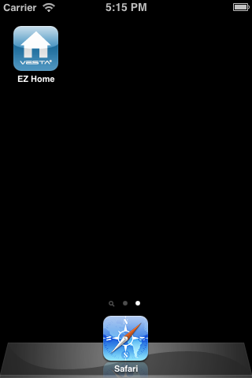
- Panel Selection
Upon starting the application, you will first enter Panel Selection menu
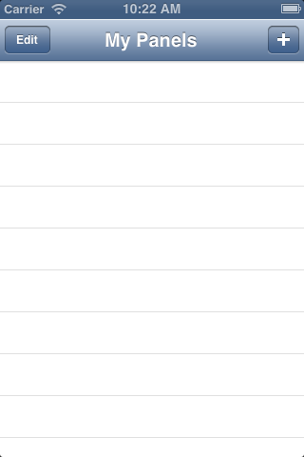
- For first time user, you need to first enter your panel information, please select the “+” icon.

- Enter the panel information, including the panel name you want to use in the application, panel SIM card number, a User PIN Code and the SMS keyword used to access the panel. Press “Done” to confirm when finished.
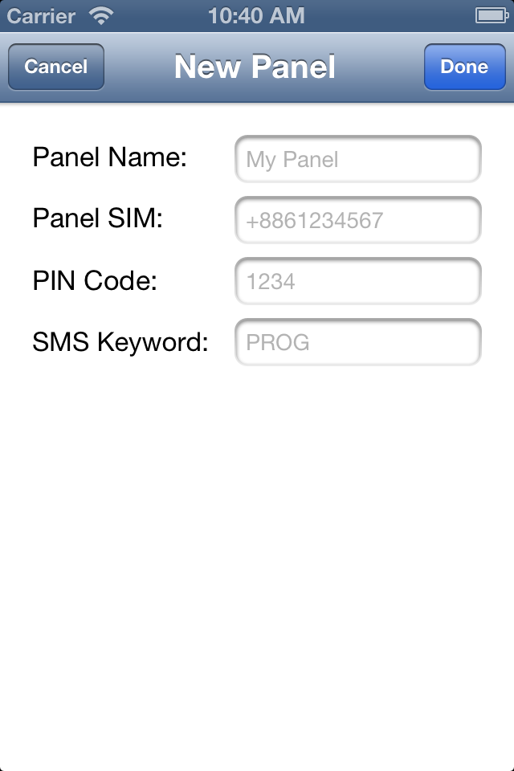
<NOTE>
        - The PIN code can be any of the programmed User PIN codes in the Control Panel.
        - You cannot change the PIN code used to send SMS command once the new panel has been created. If you want to change the PIN code, you need to delete the current panel and create a new one.
        - VST-2745 and VST-2752 does not have a default SMS Keyword, you need to program a Keyword in your panel first to use Vesta EZ Home Application. Please refer to 2.5. Panel Setting for Keyword programming.

- You will return to Panel Selection menu, the new panel you entered will be displayed, select the panel to proceed to edit SMS commands for the panel. If you want to remove the panel, press “Edit.”

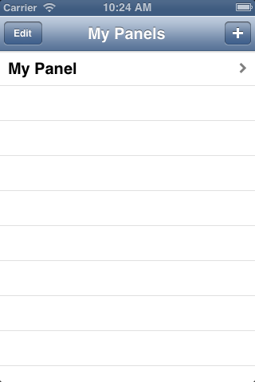
- Press the icon, then “Delete” to remove the panel from the application.
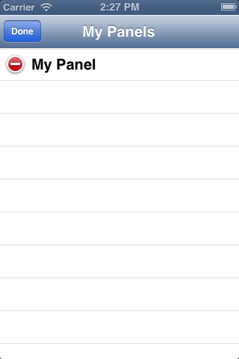

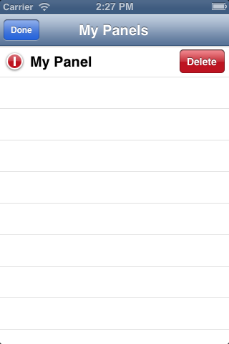
<IMPORTANT NOTE>
        - The default setting in the application may be different from the setting in your Control Panel. When you use the application to program the system for the first time, please check both application and Control Panel settings for discrepancies.
        - If there are discrepencies, please enter the correct setting in the application, and press “Save” to send the setting to Control Panel.
        - After you send an SMS command, please make sure you receive confirmation message from the Control Panel before proceeding to send the next command. If you receive an error message from the Control Panel, please resend the SMS command again, or change the setting back to previous setting and save again. Otherwise the setting saved in the application will be different from the panel setting.

- Panel Main Menu
The Panel Main Menu is displayed as follows:
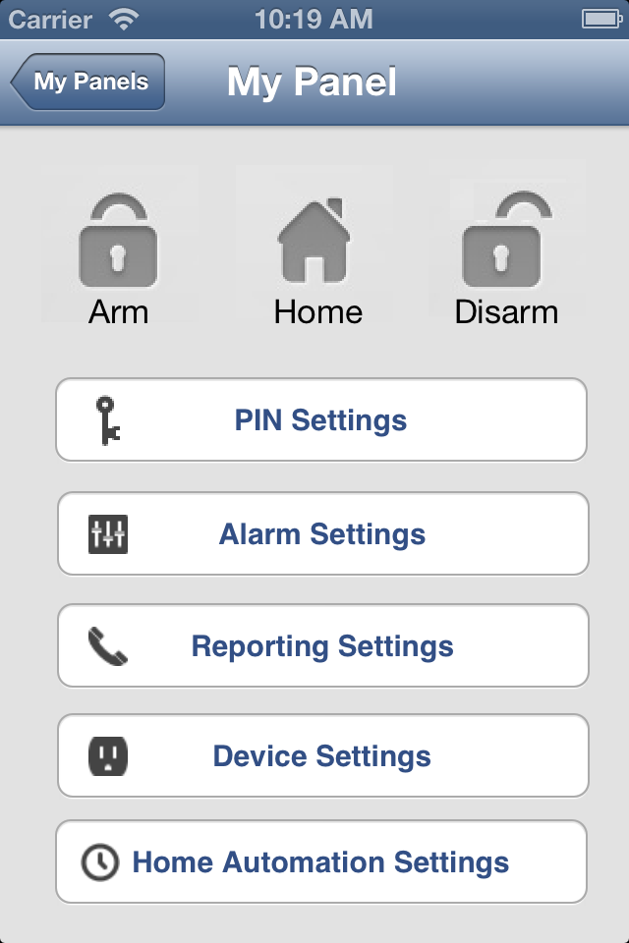
- Away Arm / Home Arm / Disarm
To change system mode, select the icon for Arm / Home / Disarm respectively. A SMS message edit screen will appear for you to confirm. Press “Send” to send the SMS command to panel.

- PIN Setting
The PIN Setting Menu allows you to edit User PIN Codes and SMS Keyword.
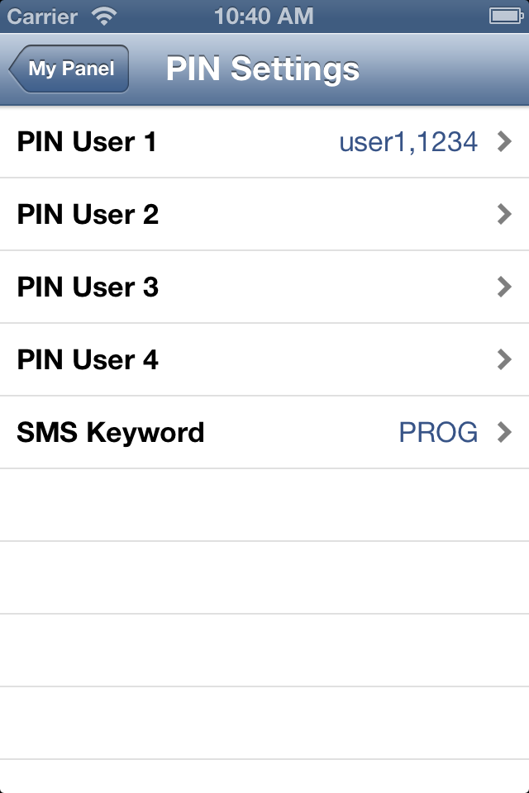
- Select the information you want to edit, enter the information and press “Save”. A SMS message edit screen will appear for you to confirm. Press “Send” to send the SMS command to panel.
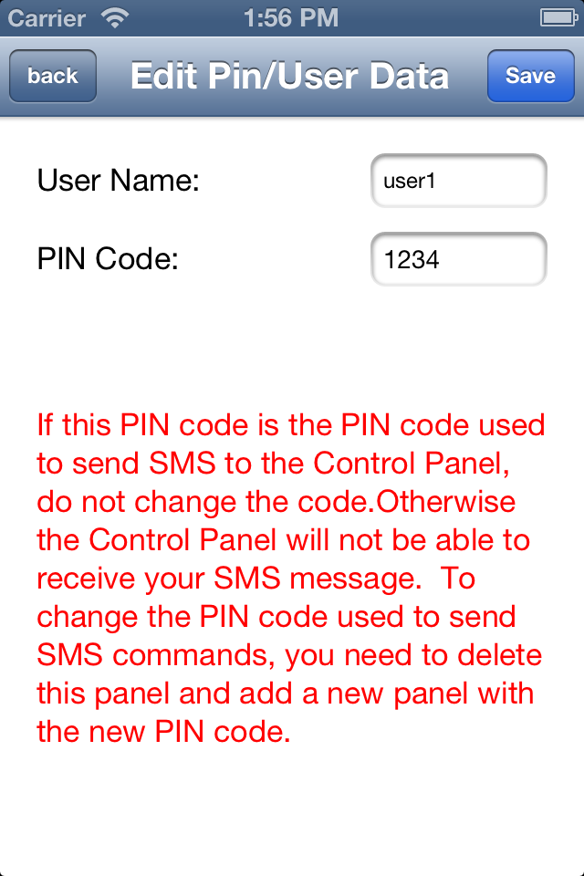

<NOTE>
        - You can delete the User PIN code by keeping the Pin Code field blank and save the setting. User PIN Code 1 cannot be deleted.”
<IMPORTANT NOTE>
        - If you change the SMS Keyword, please make sure the Control Panel successfully receives the SMS message. If the Control Panel fails to receive new SMS Keyword, you will not be able to access the system with SMS command unless you delete current panel and create a new one.
        - Take extra caution when editing your User PIN Codes so that you would not accidentally remove the PIN code you used to send SMS command to the Control Panel.

- Alarm Setting
The Alarm Setting Menu allows you to edit alarm related configuration.
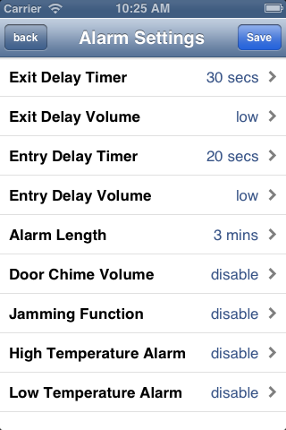

- Select the option you want to edit, you will enter the edit screen
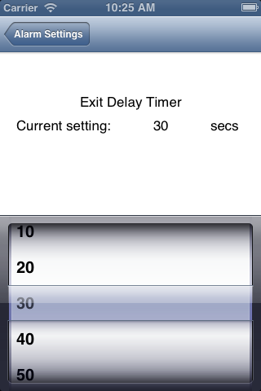
- Slide the screen to select the value you want to change, press “Alarm Setting” to return to menu when done.
- When you are satisfied with all of your alarm settings, press “Save”. A SMS message edit screen will appear for you to confirm. Press “Send” to send the SMS command to panel.

- Reporting Setting
The Report Setting Menu allows you to edit your telephone numbers for reporting.
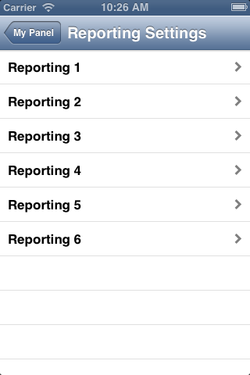
- Select the reporting priority you want to edit.
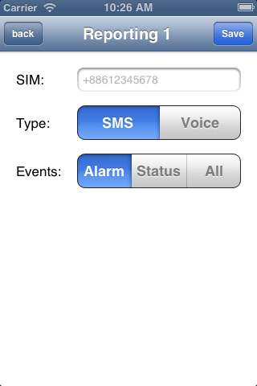
- Enter the telephone number for reporting, and select report type and events.

- Press “Save”. A SMS message edit screen will appear for you to confirm. Press “Send” to send the SMS command to panel.
<NOTE>
        - You can delete the telephone number by keeping the telephone number field blank and save the setting.

- Device Setting
The Device Setting Menu allows you to edit device, control Siren, and turn on/off PSS.
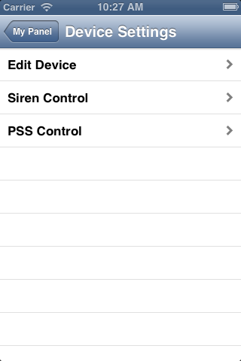

Edit Device
- The Edit Device option allows you to edit a device name, and attribute for Door Contact, PIR and EIR Sensor.
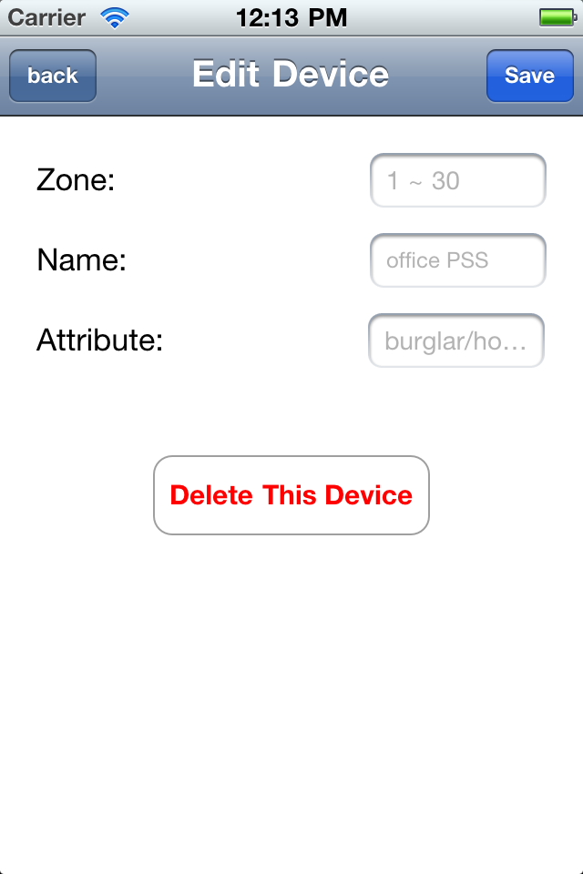
- Select the Zone number of the device you want to edit and enter a new name,
- For Door Contact and PIR Sensor, please select an attribute.
- For other devices without attribute, you can select any attribute as it will not affect the device setting.
- Press “Save”. A SMS message edit screen will appear for you to confirm. Press “Send” to send the SMS command to panel.
- You can also press “Delete This Device” to remove the device in selected zone from the Control Panel.

Siren Control
- The Siren Control option allows you to change Siren settings.
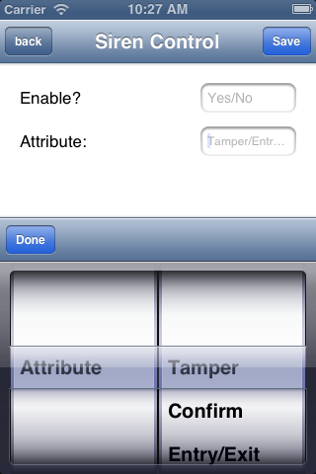
- Select the function you want to edit and choose to enable or disable the function.
- Press “Save”. A SMS message edit screen will appear for you to confirm. Press “Send” to send the SMS command to panel.

PSS Control
- The PSS Control option allows you to turn on/off your Power Switch groups.
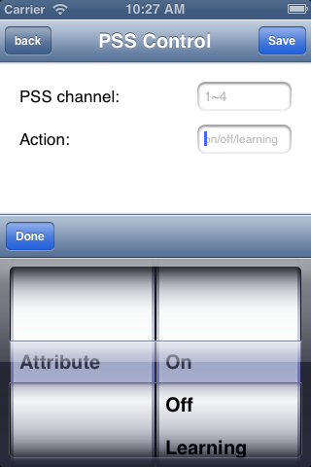
- Select the Power Switch group you want to control, then choose to turn on/off the Power Switch.
- Press “Save”. A SMS message edit screen will appear for you to confirm. Press “Send” to send the SMS command to panel.
<NOTE>
        - PSS learning is not available with Vesta EZ Home.

- Home Automation Rules
Set Home Automation rules.
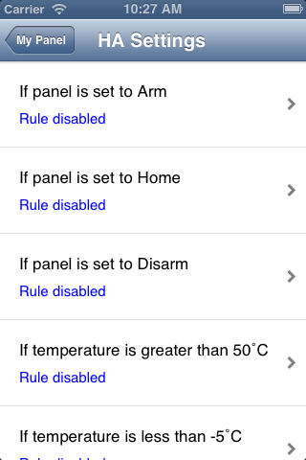
- Select the condition, you will enter the rule setting page for the condition.
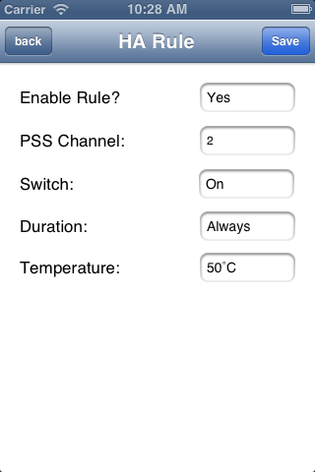
- Choose to enable/disable the rule, Power Switch group on/off status and duration. For High and Low temperature, you also need to set the temperature value.

- Press “Save”. A SMS message edit screen will appear for you to confirm. Press “Send” to send the SMS command to panel.
<NOTE>
        - For system mode change (Arm, Home, Disarm), the Power Switch Ggroup selection is limited to #1 only.
        - For High/Low Temperature and Time setting. You can select any Power Switch group from #1 ~ #4.

5.2. For Android Phone
The Android version of Vesta EZ Home Application supports complete SMS command functions, including the commands to inquire Control Panel setting and update appllication data with latest setting information.
An Adroid version of 2.2 or hight is required to use Vesta EZ Home on your Andriod phone.
Select the Vesta EZ Home icon to start the application.
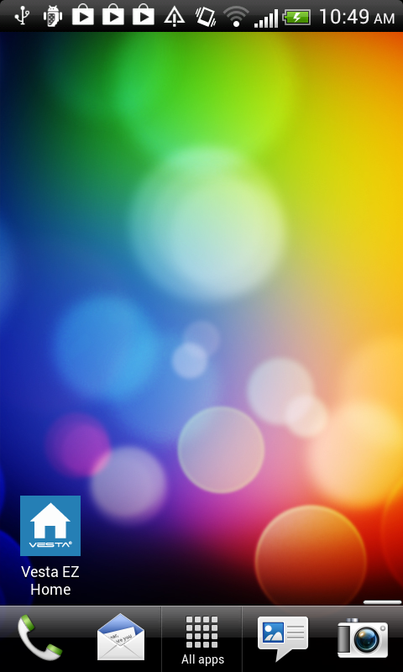

- Panel Selection
Upon starting the application, you will first enter Panel Selection menu
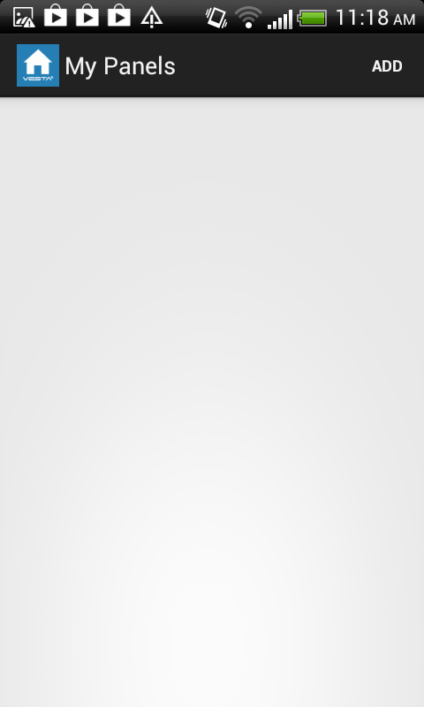
- For first time user, you need to first enter your panel information, please press “ADD” button.
- You will see the panel information, including the panel name you want to use in the application, panel SIM card number, the PIN Code and SMS keyword used to access the panel. Press “Save” to confirm when finished.
<NOTE>
        - The PIN code can be any of the programmed User PIN codes in the Control Panel.
        - You cannot change the PIN code used to send SMS command once the new panel has been created. If you want to change the PIN code, you need to delete the current panel and create a new one.
        - VST-2745 and VST-2752 does not have a default SMS Keyword, you need to program a Keyword in your panel first to use Vesta EZ Home Application. Please refer to 2.5. Panel Setting for Keyword programming..

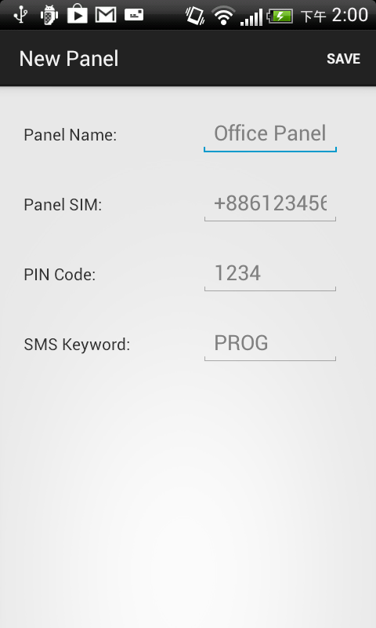
- You will return to Panel Selection menu, the new panel you entered will be displayed, select the panel to proceed to edit SMS commands for the panel.
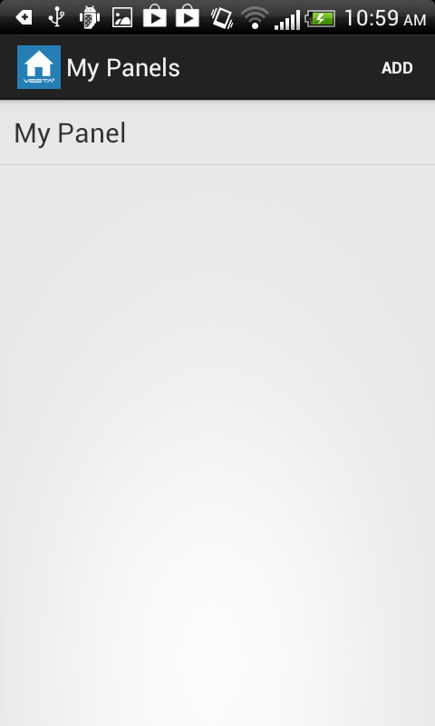

<IMPORTANT NOTE>
        - Whenever you send an SMS command, please make sure you receive confirmation message from the Control Panel before proceeding to send the next command. If you receive an error message from the Control Panel, please resend the SMS command again, or change the setting back to previous setting and save again. Otherwise the setting saved in the application will be different from the panel setting.

- Panel Main Menu
The Panel Main Menu is displayed as follow:
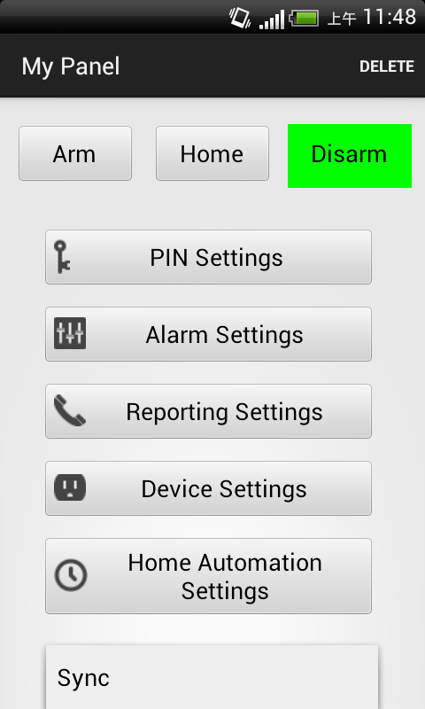
You can select the different settings to further program different functions. Pressing “Back” button on your Android phone will return to Panel Selection Menu.

- Delete Panel
To delete current selected panel, press “Delete,” you will be asked confirm the action, select “OK” to delete the panel and return to Panel Selection menu.

- Away Arm / Home Arm / Disarm
To change system mode, Press the Arm / Home / Disarm button respectively. The phone will send a SMS command to panel to execute the command.

- Sync with Panel
Press the Menu button on you Android phone to bring up the “Sync” option. Press “Sync” to send an SMS command to Control Panel requesting it to report back its current mode. Once your phone receives the SMS response message from the Control Panel, Vesta EZ Home app will update the current system mode accordingly for you to view. Please remember to sync your Vesta EZ Home app with all your panel setting when you first create the panel.

- PIN Setting
The PIN Setting Menu allows you to edit User PIN Codes and SMS Keyword.
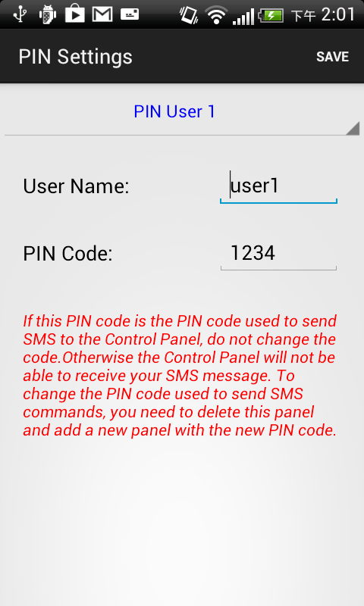

- Select the top column to choose the setting you want to edit
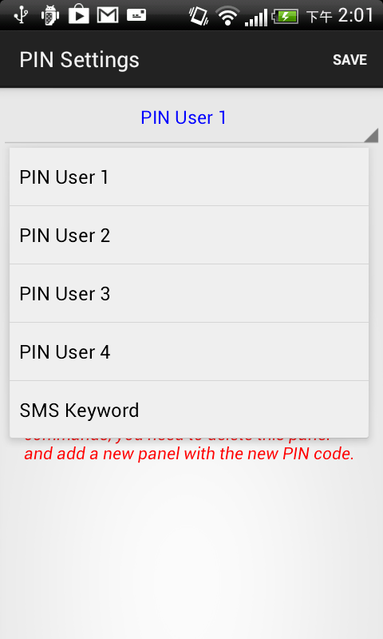

- Select the information you want to edit, enter the information and press “Save”. The phone will send a SMS command to panel.
<NOTE>
        - You can delete the User PIN code by keeping the Pin Code field blank and save the setting. User PIN Code 1 cannot be deleted.”
<IMPORTANT NOTE>
        - If you change the SMS Keyword, please make sure the Control Panel successfully receives the SMS message. If the Control Panel fails to receive new SMS Keyword, you will not be able to access the system with SMS command unless you delete current panel and create a new one.
        - Take extra caution when editing your User PIN Codes so that you would not accidentally remove the PIN code you used to send SMS command to the Control Panel.

- Press the “Menu” button on your Android phone to bring up the “Sync” function. Press “Sync” to send a SMS command to the Control Panel for inquiring current User PIN code setting. Once your phone receives the SMS response message from the Control Panel, Vesta EZ Home app will update the User PIN code information.
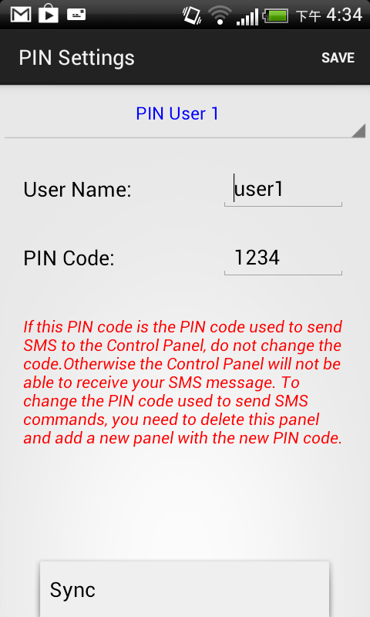

- Alarm Setting
The Alarm Setting Menu allows you to edit alarm related configuration.
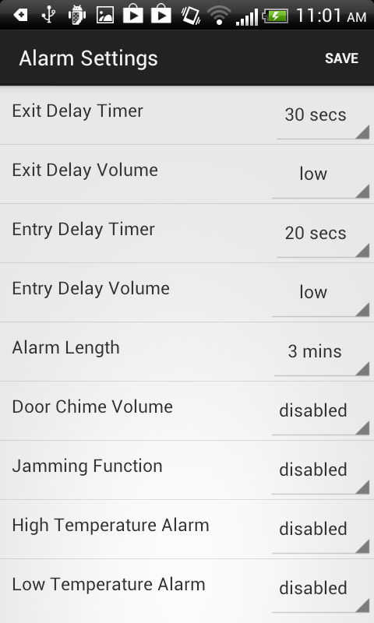
- Select the option you want to edit to change the setting.
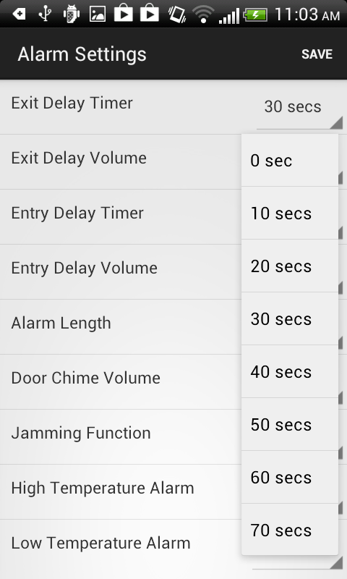
- When you are satisfied with all of your alarm settings, press “Save”. The phone will send a SMS command to panel.

- You can press the “Menu” button on your Android phone to bring up the “Sync” options and choose to sync either the configurations or high/low temperature setting.
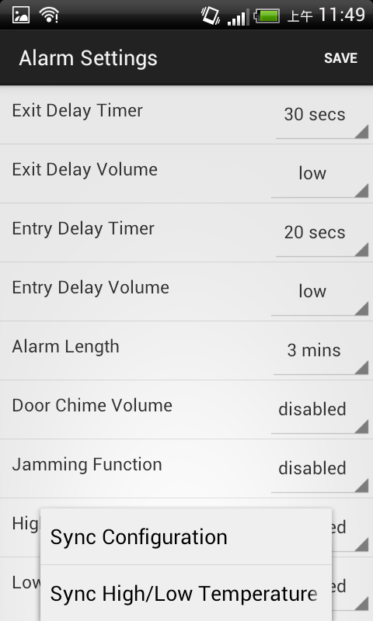

- Reporting Setting
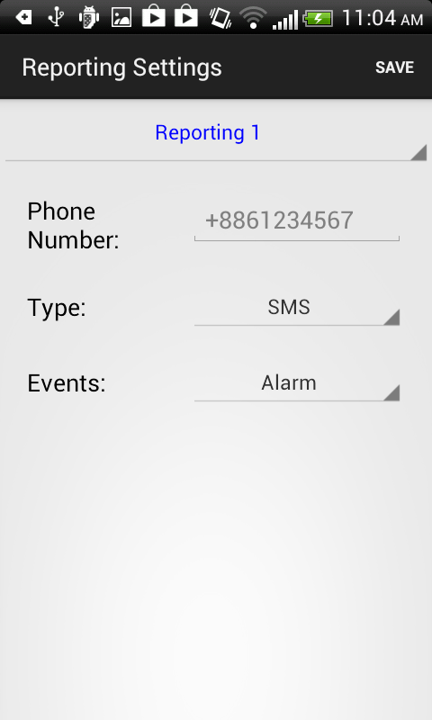
The Report Setting Menu allows you to edit your telephone numbers for reporting.

- Select the top column to select the reporting priority you want to edit.
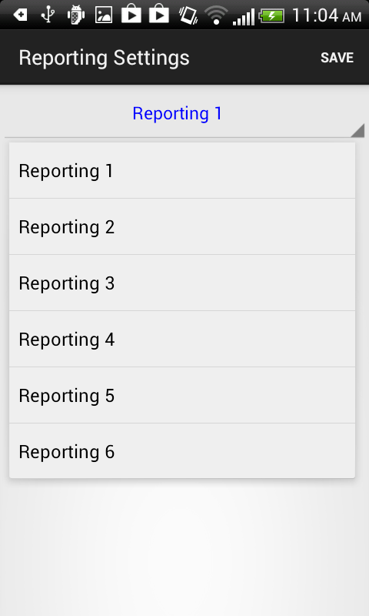
- Enter the telephone number for reporting, and select report type and events.
- Press “Save”. The phone will send a SMS message to panel.
<NOTE>
        - You can delete the telephone number by keeping the telephone number field blank and save the setting.

- You can press the “Menu” button on your Android phone to bring up the “Sync” options and choose to sync either Reporting 1~3 or 4~6.
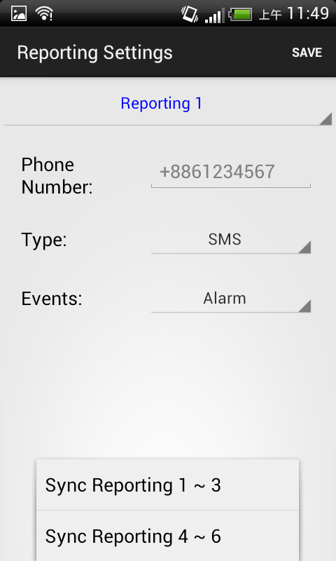

- Device Setting
The Device Setting Menu allows you to edit device, control Siren, and turn on/off PSS.
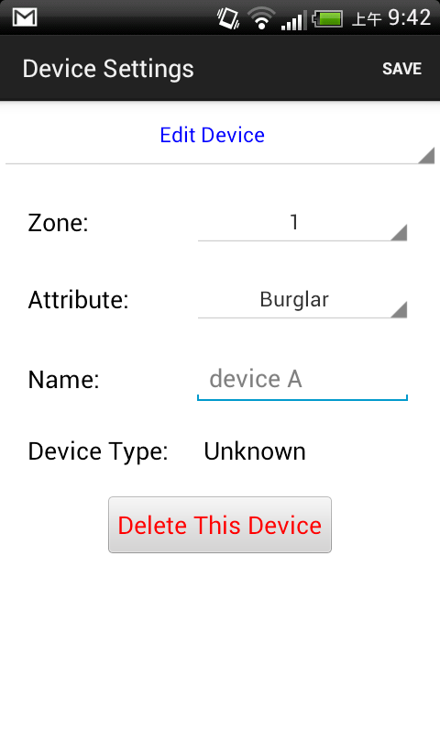
- Select the top column to choose between Edit Device, Siren Control, and PSS Control.
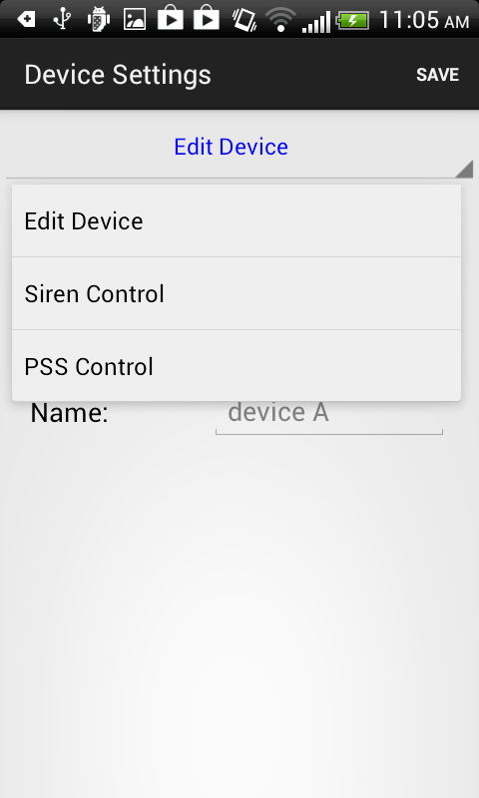

Edit Device
- The Edit Device option allows you to edit a device name, and attribute for Door Contact, PIR and EIR Sensor.
- Select the Zone number of the device you want to edit and enter a new name,
- For Door Contact and PIR Sensor, please select an attribute.
- For other devices without attribute, you can select any attribute as it will not affect the device setting.
- Press “Save”. The phone will send a SMS command to panel.
- You can press the “Menu” button on your Android phone to bring up the “Sync” options and choose to sync device information in different zones.
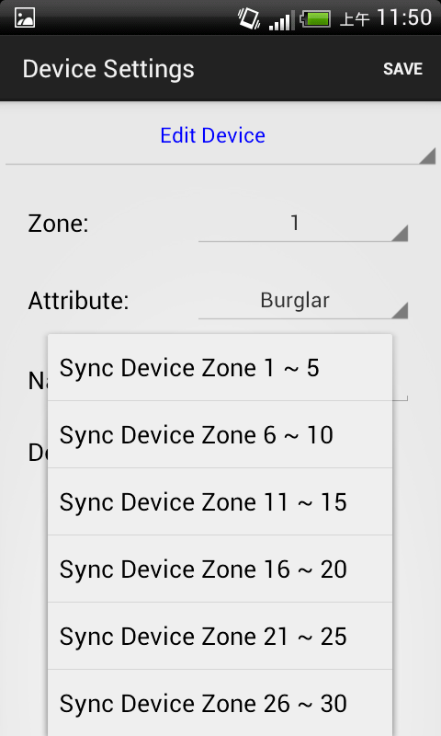
- “Device Type” information will only be updated after you successfully synced with the Control Panel
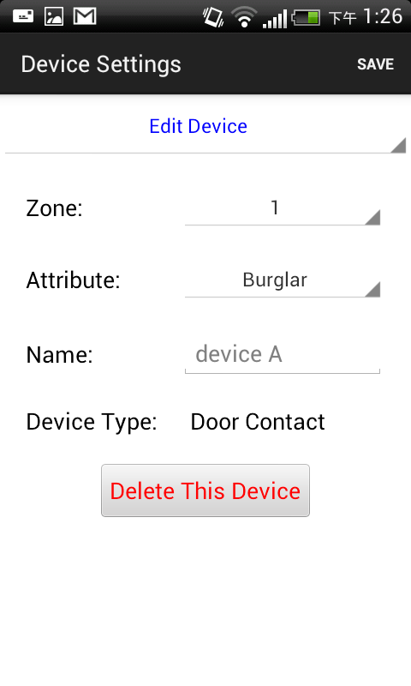

Siren Control
- The Siren Control option allows you to change Siren settings.
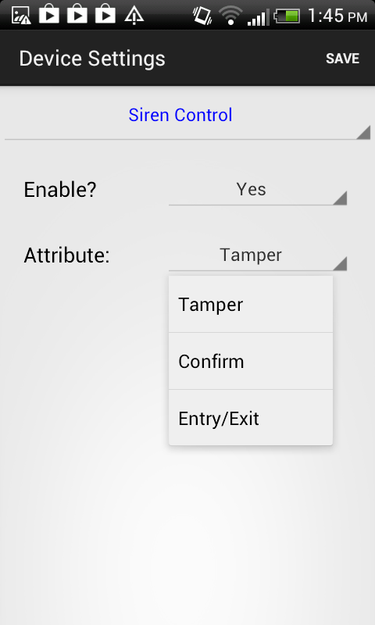
- Select the attribute and choose to enable or disable the function.
- Press “Save”. The phone will send a SMS command to panel.

.

PSS Control
- The PSS Control option allows you to turn on/off your Power Switch.
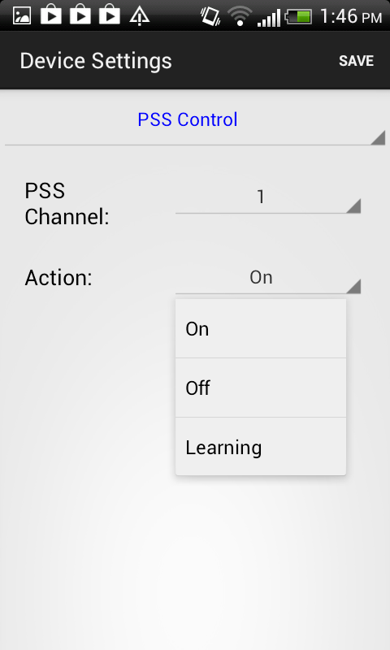
- Select the Power Switch group you want to control, then choose to turn on/off the Power Switch.
- Press “Save”. A SMS message edit screen will appear for you to confirm. The phone will send a SMS command to panel.
<NOTE>
        - PSS learning is not available with Vesta EZ Home.

- Home Automation Rules
Set Home Automation rules.
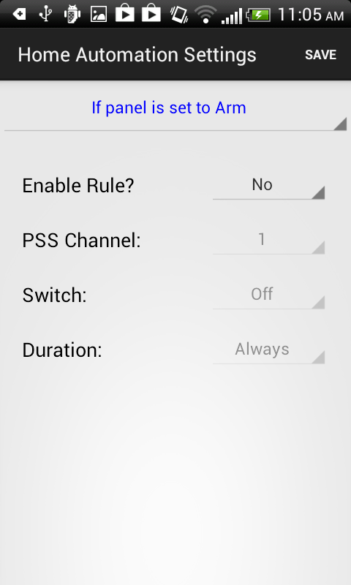
- Select the top column to choose different conditions.
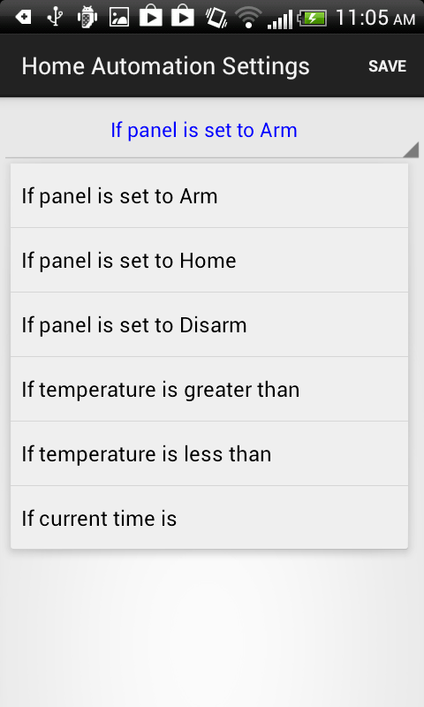
- Choose to enable/disable the rule, Power Switch group on/off status and duration. For High and Low temperature, you also need to set the temperature value.

- Press “Save”. A SMS message edit screen will appear for you to confirm. The phone will send a SMS command to panel.
<NOTE>
        - For system mode change (Arm, Home, Disarm), the Power Switch group selection is limited to #1 only.
        - For High/Low Temperature and Time setting. You can select any Power Switch group from #1 ~ #4.

6. Appendix

5.1. Event Code
- 100 – Medical
- 101 – Personal emergency
    - When the Wrist Transmitter / Emergency Pendant (WTR) is pressed.
- 102 – Inactive
- 110 – Fire
- 111 – Smoke
    - When the Smoke Detector (SD) is triggered.
- 114 – Heat
    - When the Heat Detector (HD) is triggered.
- 120 – Panic
    - When the Panic Button of the Remote Controller (RC) is pressed.
- 121 – Duress
    - When the Duress Code is entered to disarm or arm the system.
- 122 – Silent Panic
    - When the panic button on a Remote Controller (RC) set to silent panic is pressed.
- 130 – Burglar
    - When any one of the following devices is triggered:
      - The Door Contact (DC) set at Burglar (@ B)
      - The Door Contact (DC) set at 24 Hours (@ H)
      - The Door Contact (DC) set at Delay (@ D)
      - The PIR set at Burglar (@ B)
      - The PIR set at Delay (@ D)
- 131 – Burglar Perimeter
    - When a device set as Entry is triggered in away arm mode.
- 132 – Burglar Interior
    - When a device set at Entry is triggered in home arm mode.

- 137 – Panel Tamper
    - When the Control Panel tamper switch is triggered.
- 139 – Verification / Alarm Confirmation
- 147 – Sensor Supervisor Failure
    - When the Control Panel fails to receive the signal transmitted from any one of the devices individually for a preset period.
- 151 – Gas
- 154 – Water leakage
    - When a Water Sensor or Door Contact set as Water is triggered.
- 158 – High Temperature
    - When the temperature exceeds High Temperature setting.
- 159 – Low Temperature
    - When the temperature drops below Low Temperature setting.
- 162 – CO detector
- 301 – AC Failure
    - When the AC power fails for more than 10 sec.
- 302 – Low Battery
    - When the battery voltage of the Panel and any one of the devices is low.
- 311 – Panel Battery Missing/Dead
    - When the Control Panel Battery is missing or disconnected.
- 344 – Interference
- 374 – Arm with Fault
    - When fault exists in system, and the system is armed by confirming the arm action. (Arm Fault Type set to Confirm.)
- 383 – Device Tamper
    - When a device’s tamper switch is triggered.
- 384 – Device Low Battery
    - When a device’s is under low battery.
- 389 – Self Test Failure
- 400 – Arm/Disarm (by Remote Controller)
    - When the system is armed or disarmed by using the Remote Controller.
- 401 – Arm/Disarm by Panel
    - When the system is armed or disarmed by entering the PIN code.
- 408 – Set/Unset Disarm
- 407 – Disarm/Away Arm/Home Arm by Remote Keypad
- 465 – Alarm Reset
- 570 – Zone Bypass
    - When fault exists in system, and the system is armed by ignoring the fault event. (Arm Fault Type set to Direct Arm)
- 602 – Periodic test report
    - When Control Panel makes periodic Check-in reporting.
- 606 - Follow-On Function
    - When Control Panel reports to CMS to request opening Listen-in function. (VST-2745/2752 only)

